ESDE Assignment Two

By:

Mohammed Aamir P2004163

Lim Ze Kai P2026718

Class: DIT/FT/2A/01

Table of contents

Table of contents 2

Introduction 4

Setting up our AWS Account 5

Setting up a new Instance 6

Configuring our EC2 Instance 9

Setting Up WINSCP 14

Installing and initializing WinSCP, PuTTY 14

Setting up WinSCP 15

Configuring ubuntu machine 19

Running the web application on the browser 20

Setting Up Amazon RDS Database 21

Configuring backend code 25

Setting up new connection using MySQL Workbench 26

Refactor frontend JS files 28

Transferring backend function to AWS 29

Configuring Cloud 9 30

Configuring DynamoDB 35

Populating our DynamoDB Table 36

Setting up Lambda Functions 41

Configuring Lambda Function 45

Testing our Lambda Function 48

Setting up API Gateway 52

Testing our API Gateway 63

Testing and debugging DynamoDB, Lambda function and API Gateway, RDS 65

Centralized logging for Web API Access 68

MySQL RDS Database Security 74

Introduction

In part 1 of your assignment, our team code-reviewed the system’s code and performed vulnerability tests to give the competition committee an assurance on the preventive measures. We then Suggested fixes for the flaws, providing code snippets as necessary inside the report.

As a result, our application is now ready to be deployed to a production environment, with the resource/ services from AWS cloud provider. Amazon Web Services offers reliable, scalable, and inexpensive cloud computing services and would allow us to host the web application publicly.

# Setting up our AWS Account

Before we begin, we would require an AWS account to use their services.

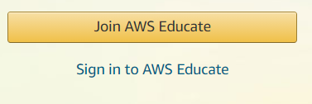

If you are a new user, click “Join AWS Educate”

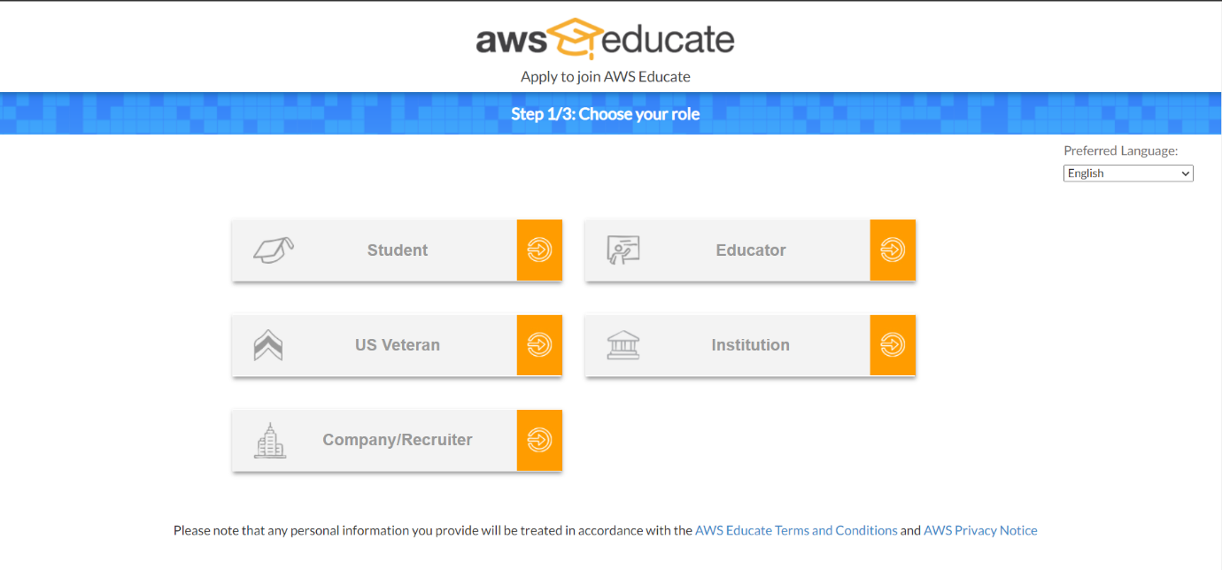Alternatively, you can sign in if you already have an existing account

Next, you can select your role and fill up the required fields prompted by AWS and you would have your AWS Account ready for use.

# Setting up a new Instance

Next, we will be setting up an Instance on AWS. We will be using the EC2 instance available in AWS. An Amazon EC2 instance is a virtual server in Amazon's Elastic Compute Cloud (EC2) for running applications on the Amazon Web Services (AWS) infrastructure.

Firstly, we would have to navigate to the AWS Management Console

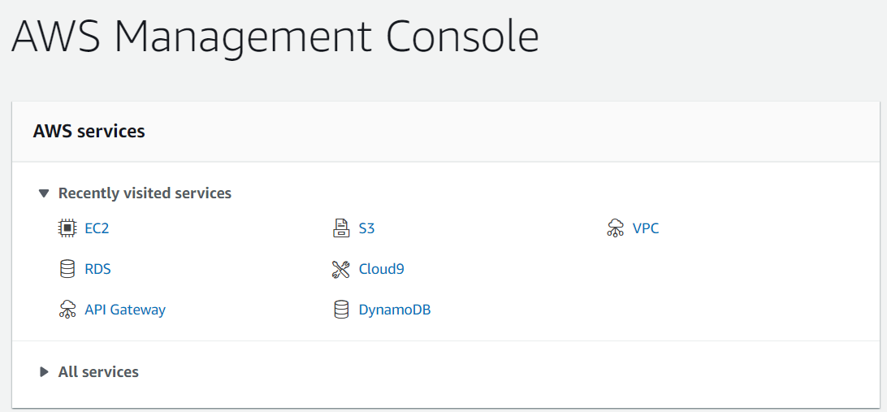

Next we would use the search bar located above the Management Console and search for EC2



After searching, click on the first item that pops up, which is the EC2 virtual server.

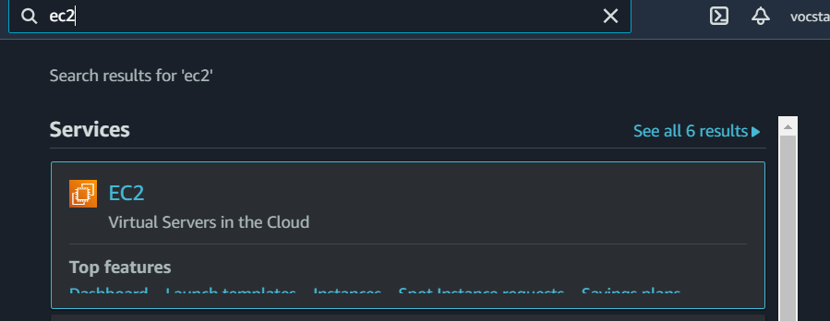

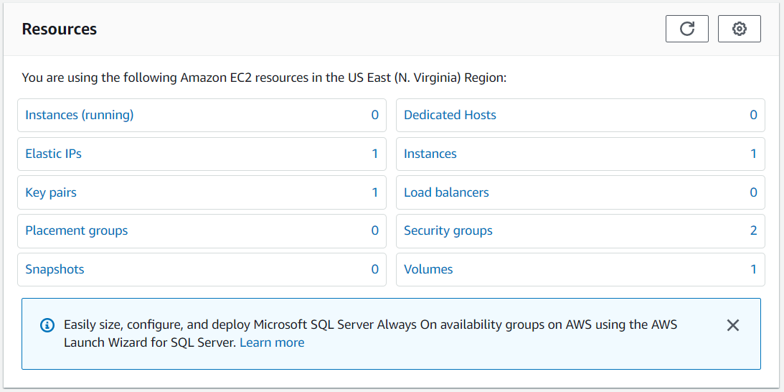Upon clicking on the EC2 instance button, it should redirect you to a panel as shown below.

Next, click “Instances”. Locate the Launch instances button on the top right hand side corner and click it.



Next, you will be prompted to select an Amazon Machine Image (AMI). Select the “Ubuntu Server 18.04 LTS” as shown below

Next, select the instance type. Choose t2.micro (default)



Next, leave every other settings as the default setting and click launch.

Next, you will be prompted to Select an existing key pair or create a new key pair. We will select “create a new key pair”. Enter a key pair name of your choice and download the keypair. Remember to store it in a safe location as we would require it later.

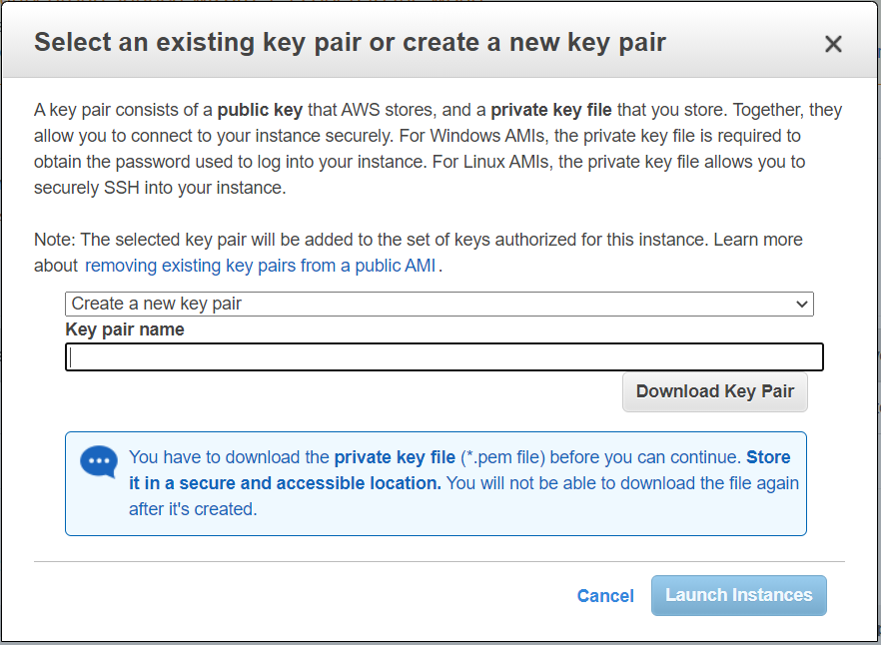

We have successfully created our EC2 instance 😊

# Configuring our EC2 Instance

Next, we will be configuring our EC2 Instance. Here, we will be allocating an Elastic IP address so that the IP address of our instance will be a fixed IP address.

We will be making use the scroll menu on the left hand side to navigate to the “Elastic IPs” as shown below.

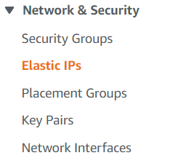

Click on the “Elastic IPs”. After doing so, click the button on the top right hand side labelled “ Allocate Elastic IP Address “ as shown below.

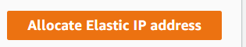

Once you have clicked on it, you should see a screen as such to configure your Elastic IP address settings.

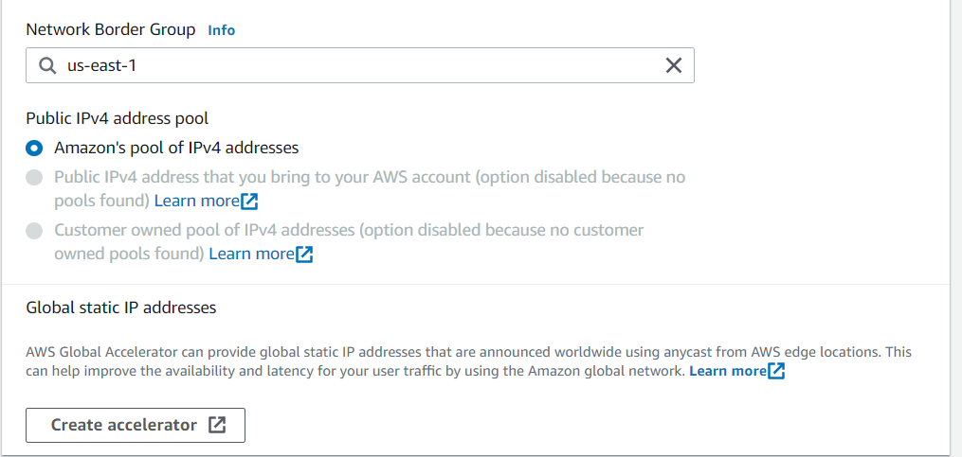

For the Network Border Group, select whichever region you wish to use. As for us, we will be making use of “us-east-1” as the Network Border Group.

For the Public IPv4 address pool, leave it as the default setting.

Next, you can click the allocate button on the bottom right-hand side.

You now would have configured your Elastic IP Address 😊

Next, you can select your configured Elastic IP address by checking the blue checkbox on the left as shown below.

We now will be associating our Elastic IP address with our EC2 instance. To do so, click the “Actions” button on the right-hand side and then select “Associate Elastic IP address” as shown below.

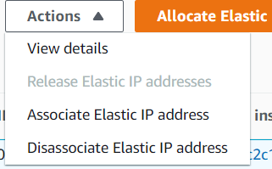

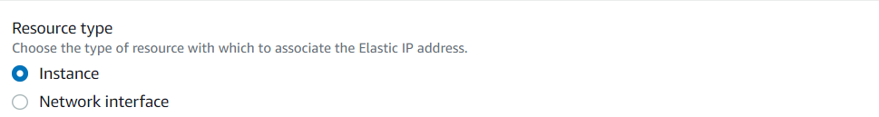Next, select the resource type and click “Instance”

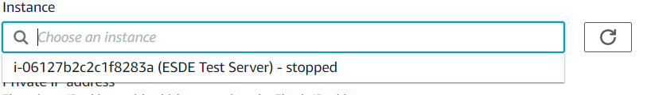Under Instance, select the instance you created in the previous steps.

Finally, click “associate” at the bottom right-hand side.

We have now successfully associated our Elastic IP address with our EC2 Instance 😊.

Next we will be working on the security groups for our EC2 Instance.

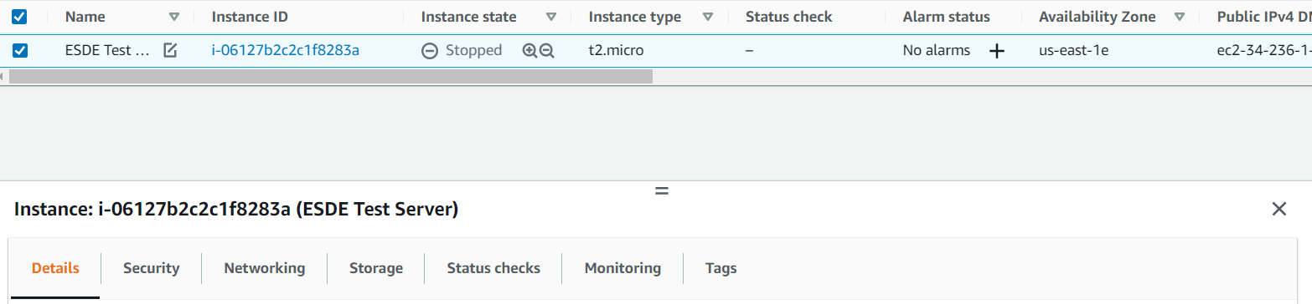First, we will select our EC2 Instance.

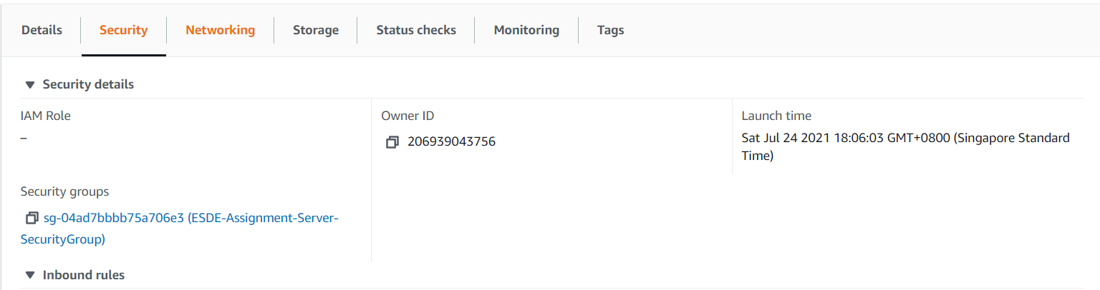Next, we will toggle over to “Security” tab beside the Details tab.

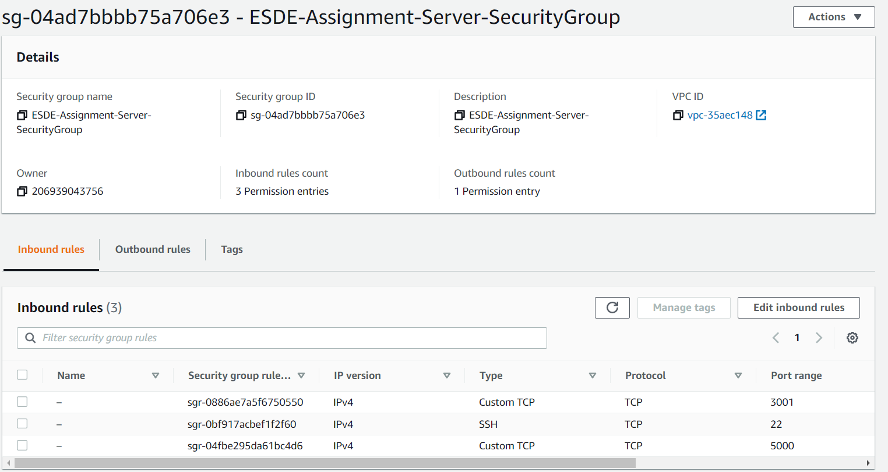Next, click on the link under the “security groups”. You should see something similar to the screenshot below.

Next, select “Edit inbound rules” near the bottom right-hand side of the screen.

Here we will be creating two new inbound rules. To do so, click the “Add rule” button at the bottom left-hand side.

We will be adding one rule for the backend server and one for the frontend server.

We will firstly add for the frontend server. Click add rule > Select Custom TCP as type and key In your frontend port number into the “Port range”

Do the same for the backend server, however, remember to change the “Port range” to your port number.

After doing everything, your screen should look something similar to the screenshot below.

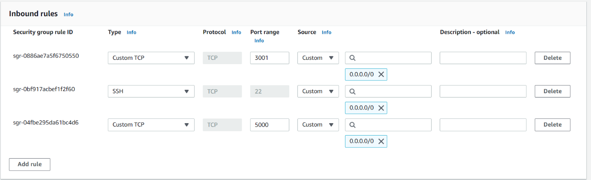

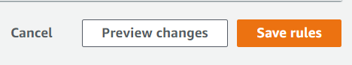Next, click the “save rules” button to save your new inbound rules.

We have successfully configured our EC2 Instance 😊

# Setting Up WINSCP

We now will set up and configure WinSCP. WinSCP is a free and open-source SSH File Transfer Protocol. Its main function is secure file transfer between a local computer and a remote server. We will also need another software called PuTTY, which is a free and open-source terminal emulator, serial console, and network file transfer application. It can also connect to a serial port.

## Installing and initializing WinSCP, PuTTY

To install WinSCP, you can use this link à <https://winscp.net/eng/download.php>

Afterwards you can follow the installation instructions that are prompted, and you will have successfully installed WinSCP.

To install PuTTY, you can use this link 🡪

<https://www.chiark.greenend.org.uk/~sgtatham/putty/latest.html>

After heading to the link, you can install the version which you wish to install on your desktop and follow the installation instructions that are prompted. You will have PuTTY installed successfully.

# Setting up WinSCP

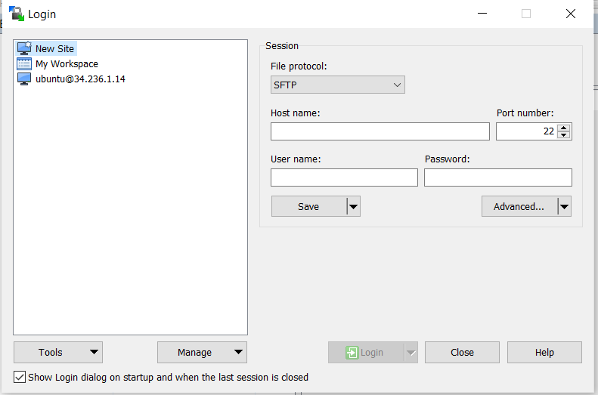After installing WinSCP, you should see a similar screen as shown below

To perform a login, here are the steps required

1) Change “File protocol:” to SCP

2) Enter your Elastic IP Address in the “Host name”

3) Enter “User name” as “ubuntu”. Make sure it is exactly the same.

Your screen should look something similar to the screenshot below.

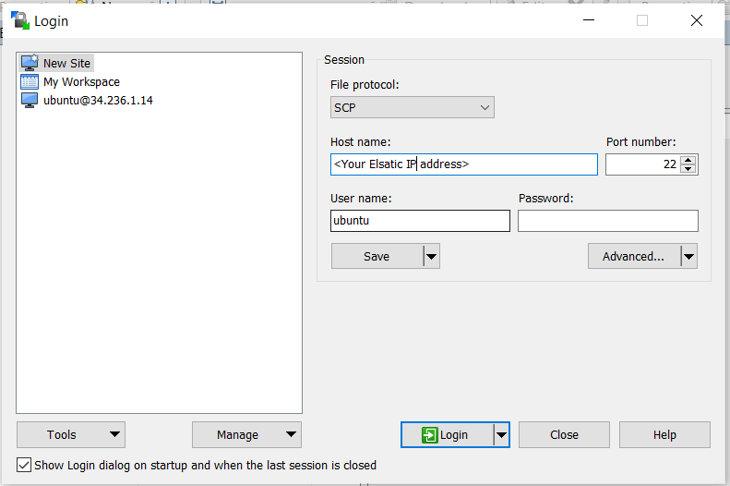

4) Next, click the “Advanced” button. Head over to “Authentication”. Afterwards, open the private key file which we saved before by clicking the 3 dots near the input box for “private key file”. Make sure to select the file type as “PuTTY Private Key Files(*.ppk)”.

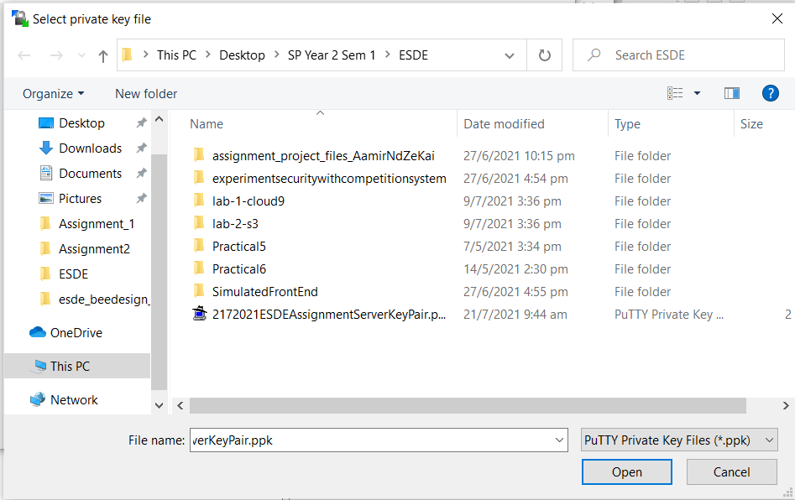

Your screen should look something similar after completing steps 1-4 to the screenshot below.

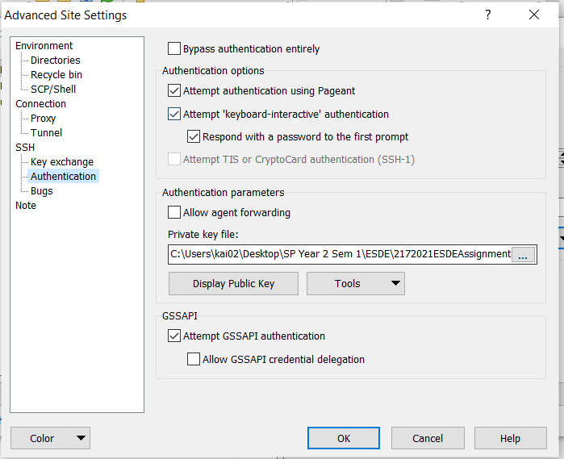

You are now ready to login to WinSCP. Click the “Login” button to login.

After logging in, you should see a split screen as shown below

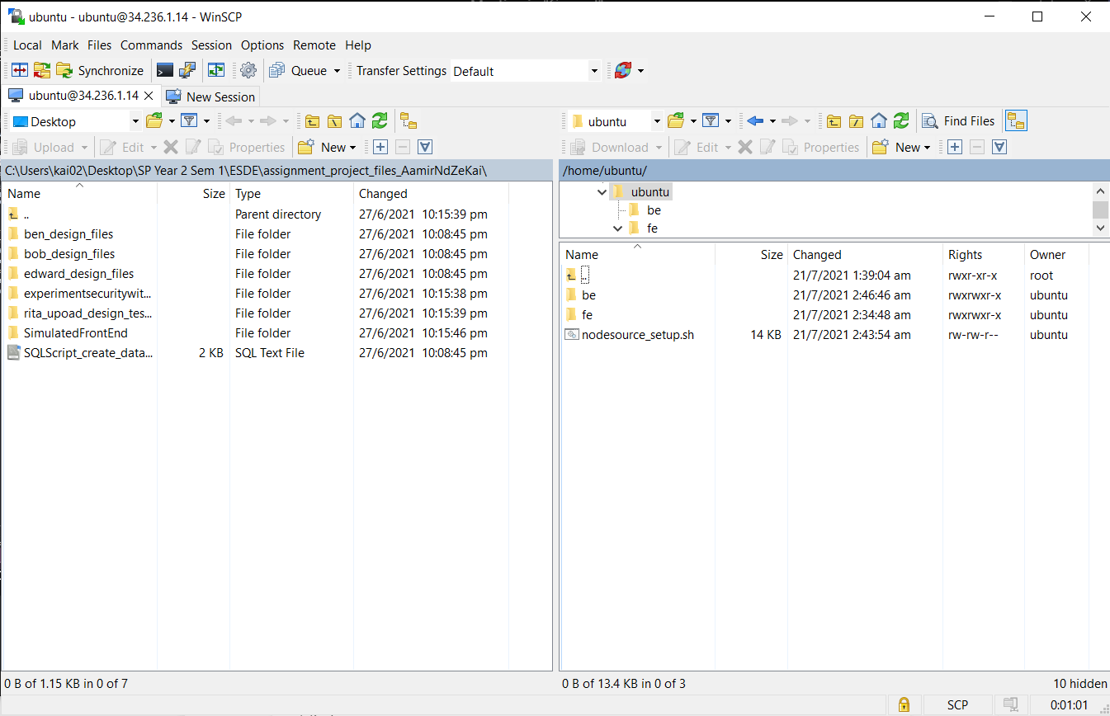

On the left screen, open up your existing project files. Next, copy and paste them into the ubuntu folder on the right screen. Make sure to have two folders called frontend and backend (you can name them anything else as long as you know which is the frontend and backend files). This step is to transfer our project files into EC2. DO NOT COPY THE NODE MODULES! This is because it will take a long time to transfer node files to the EC2. We will install node modules manually later.

Next, we will be installing NodeJS onto our ubuntu machine in WinSCP.

To do so, open up a session terminal in PuTTY using WinSCP as shown below.

The icon to open up a session is the following icon à 

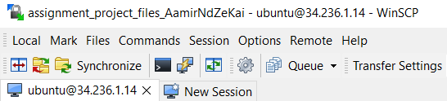

Next, a session terminal should pop up as shown below

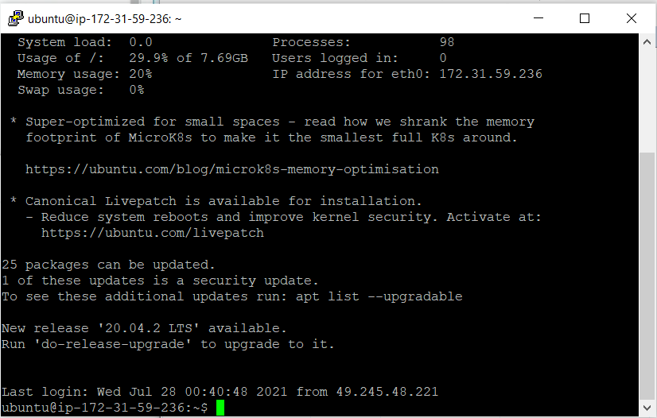

## Configuring ubuntu machine

We will now be installing nodejs on our ubuntu machine.

Firstly, in the base session terminal, we are going to run the following commands

1. sudo apt update
2. sudo apt install npm
3. curl -sL https://deb.nodesource.com/setup_14.x -o nodesource_setup.sh sudo bash nodesource_setup.sh
4. sudo apt install nodejs
5. nodejs -v (this command is to check the nodejs version you installed in step 4 and to make sure it is version 14 and above)
6. sudo apt install build-essential

Next, Open up two session terminals, one for the frontend, one for the backend. cd into the frontend and backend files using the session terminal. After doing so, you can follow the steps below.

1. Cd into your frontend files on the first session terminal
2. Cd into you backend files on your second terminal
3. Next, run the following command 🡪 ”npm install” , to install node modules.

After the steps above, the required node modules would have been installed successfully.

Next, Open up the frontend folder. Head over to index.js and open it up.

At this section, find the line that has “ .listen” and remove the variable “hostname”.

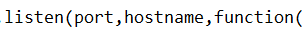

After doing so, it should look similar to the screenshot below.



## Running the web application on the browser

We are now ready to run and host our frontend on our browser. To do so, open up a session terminal and cd into the frontend folder.

Next run the following command 🡪 “nodejs index.js” and your server should have started running.

To open up the web application on the browser, you can head back to the EC2 instance console page in AWS and find the IP address.



Next to the IP Address, you can click the “open address” button. Afterwards add the port number that you are using at the back of the URL, and make sure there is a colon before it. For example, “:3001”.

Your URL should look something similar to this 🡪

<https://34.236.1.14:3001/>

Your website should now be able to be displayed on the web browser as shown below.



# Setting Up Amazon RDS Database

We are now going to be setting up our Amazon RDS Database to hold our backend data. RDS, which stands for Relational Database Service, is a web service that makes it easier to set up, operate, and scale a relational database in the AWS Cloud. It provides cost-efficient, resizable capacity for an industry-standard relational database and manages common database administration tasks.

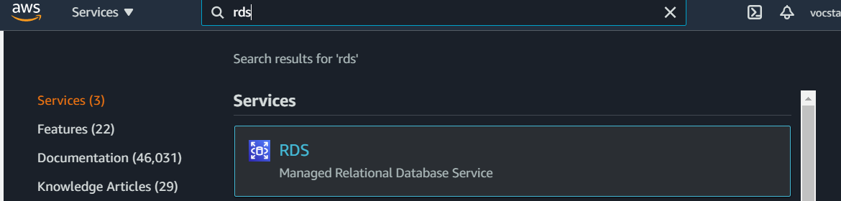To set up RDS Database, firstly, we need to head over to AWS Console and search for “rds”.

You should see a similar screen to the one above. Click the “RDS” service which pops up.

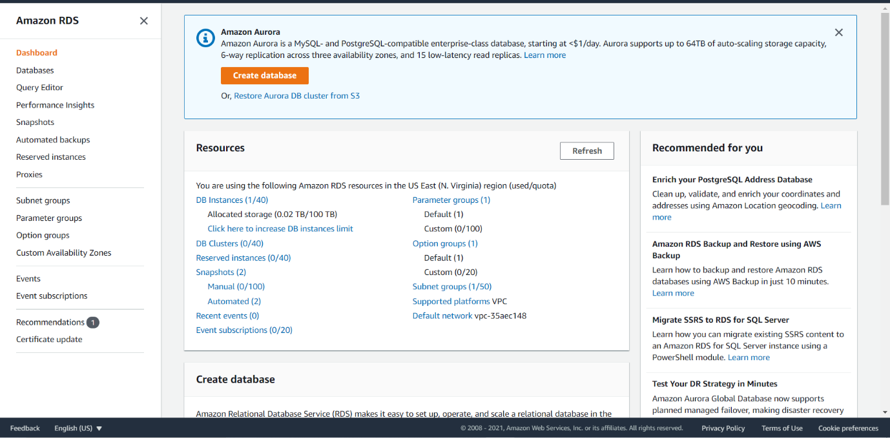

It should then bring you over to the RDS Console as shown above. Next, click the “Create Database” button in orange as you see above. We now will creating and configuring our RDS Database here.

To configure :

Select “MySQL” for the Engine type.

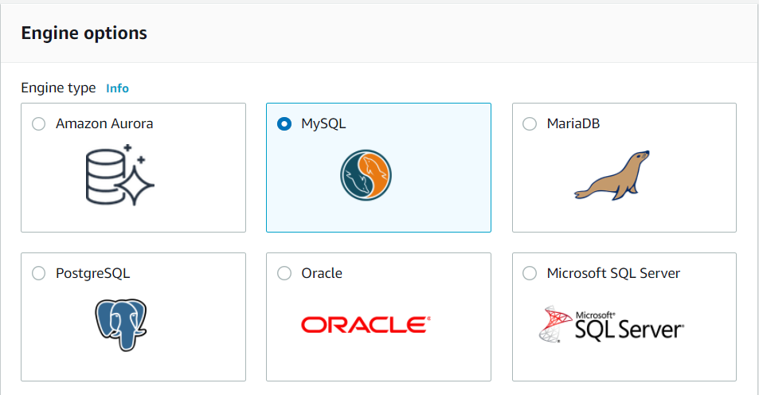

Next, Select “Free tier” for the template

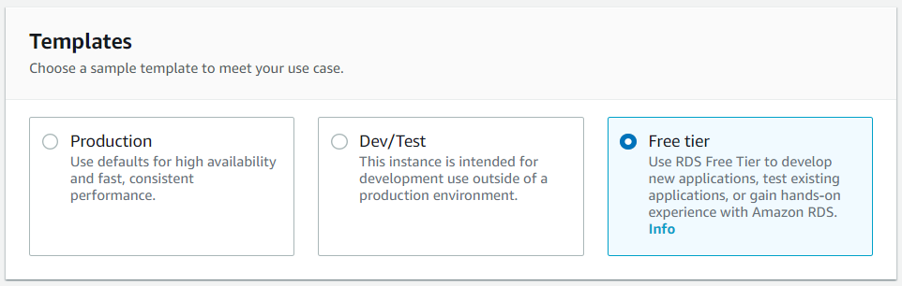

Next, enter the credentials in the screen shown below

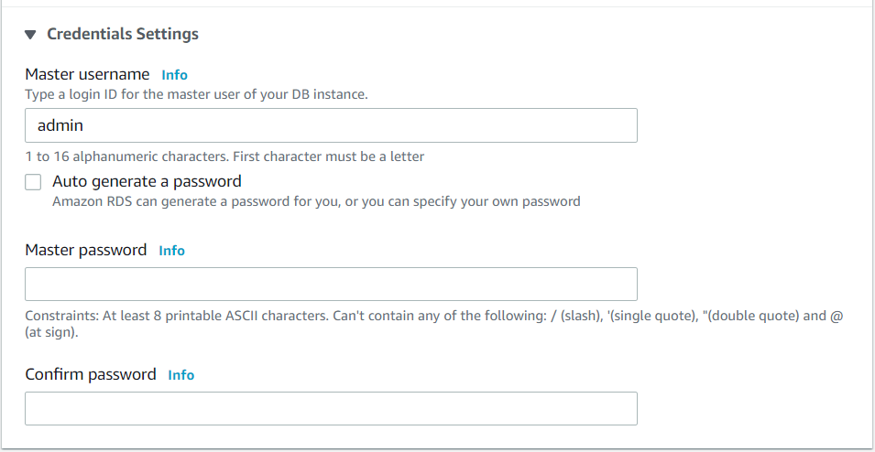

When entering your credentials on this page, make sure you store and save them in a secure place as we would be requiring this in the later part.

Next, enable “Public access”

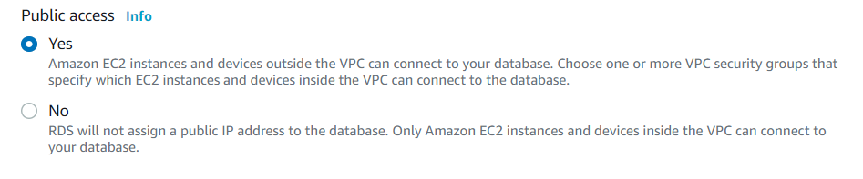

The rest of the configuration settings can be left as default, and you can complete your creation of your RDS Database.

Afterwards, we will need to configure the security groups for the RDS Database

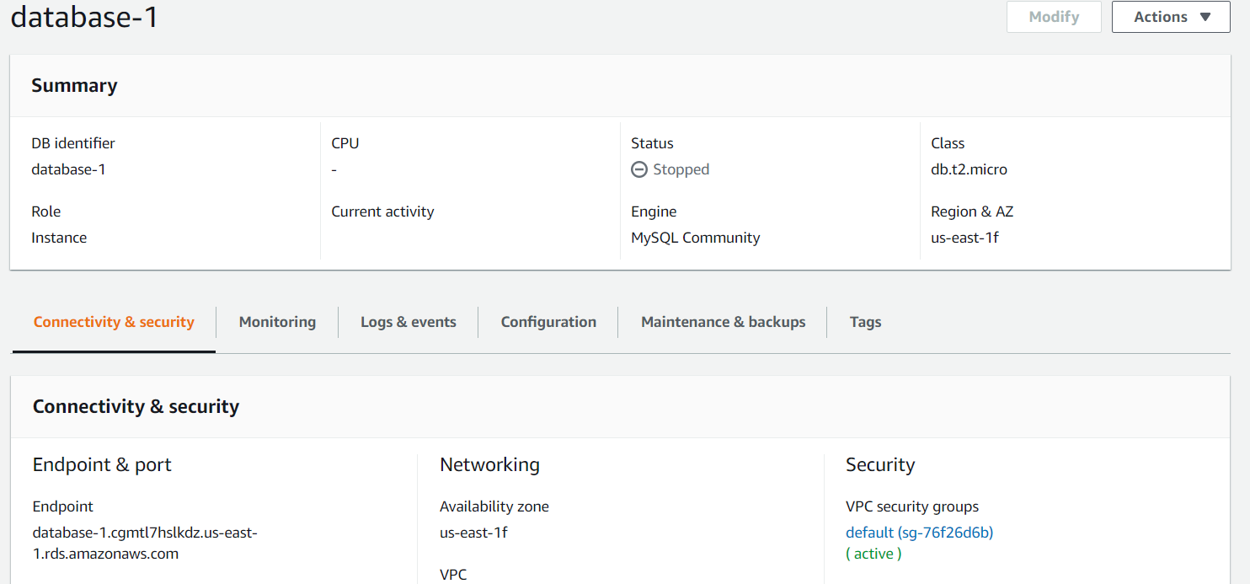

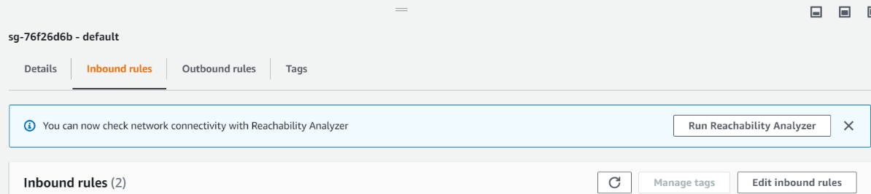Click the link under “VPC security groups” in the Security Section. Go to Inbound rules and select “Edit Inbound rules”

Select “Add rule”. Then configure the new rule as shown below.



We have now configured the security groups for our RDS Database.

# Configuring backend code

We will now be updating our backend code to use our new database that we just created.

To do so, we will head over to WinSCP and then go into our backend folder 🡪 src 🡪 config 🡪 database.js

Then inside database.js, you will need to change the following fields in the file.

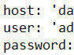

For the “host” field, you will need to head over to RDS Database and select the created database. Then, it should be shown under “Endpoint & port”. Copy the Endpoint and replace the “host” field with it.

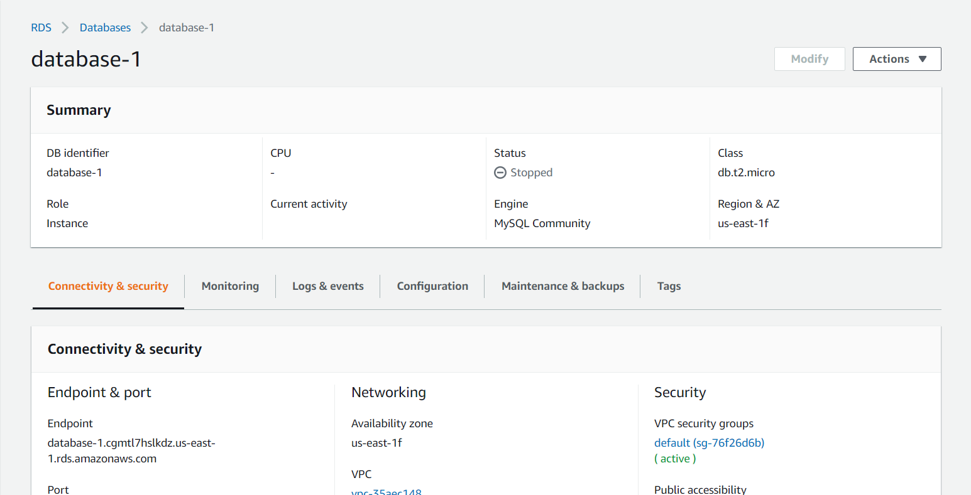

For the user and password, you should use the master username and master password that you used when creating the database above. So if your username was “admin” , your user in the database.js file will be “admin” too

We have now created and configured our RDS Database successfully 😊

# Setting up new connection using MySQL Workbench

We will now be adding a new connection to our MySQL Workbench to connect to our RDS Database that we created.

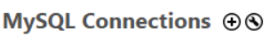

To create a new connection, click the “+” icon next to the MySQL Connections as shown above.

Next, you should see a similar screen as shown below.

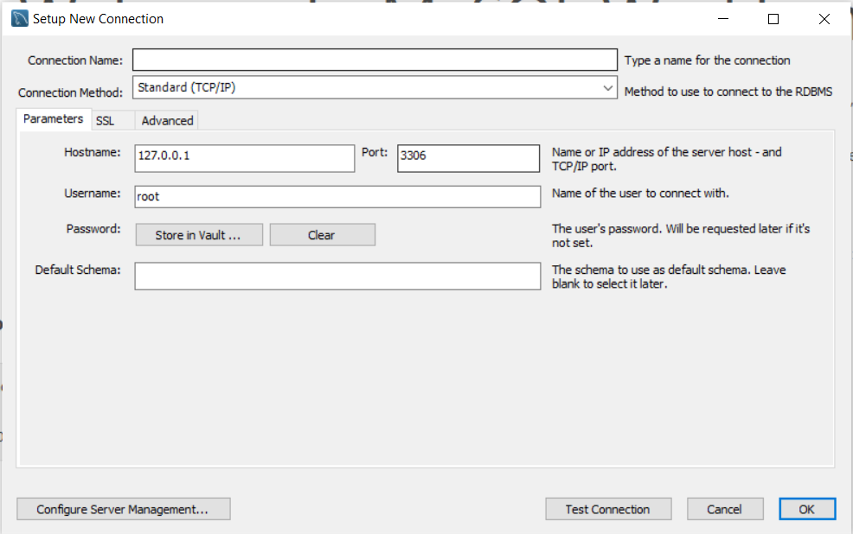

Over here, we will be filling up the fields to Setup our new connection

1) Enter the “Hostname” with your RDS Endpoint that we previously copied

2) Enter your “Username” as your master username that you used during RDS database creation

3) Click “Store in Vault …” next to password. Enter your “Password” as your master username that you used during RDS database creation

4) Click “OK”

Next, we will be creating the tables inside the new connection that we just created. Create the following tables inside a new schema as shown below. Make sure that the schema name is the same as your old schema name and the table names are the same as well.

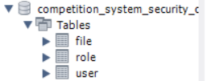

Next, we will need to populate the tables. To do so, we will now need to head over to our MySQL Table. Right click each table in our old MySQL database and select “Table Data Export Wizard” as shown below

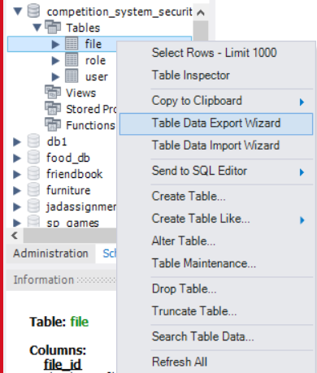

Click next and use default options aside from your file path. Make sure to store the Table export file in a secure place as we will require it later on.

Next go into our new MySQL database and right click the new tables, and select “Table Data Import Wizard”. Now, select the files that you exported earlier for each table to be imported.

The table’s data should now be imported successfully.

# Refactor frontend JS files

We will now be refactoring our frontend code that interfaces with our backend such that it uses our new EC2 instance IP Address instead of the old one. To do so, go into WinSCP 🡪 frontend folder 🡪 public 🡪 js.

Enter each file and do a find and replace by clicking “Ctrl + H” and replace all instances of the word localhost with your EC2 IP Address as shown below.

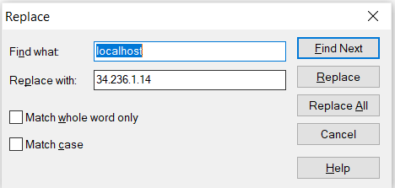

Make sure you enter each file and do the same!

# Transferring backend function to AWS

Next, in this section, we will be configuring Cloud 9, DynamoDB, and Lambda functions along with an amazon service called API Gateway, in order to transfer our backend function to AWS.

These are the reasons why we require the following amazon features/services:

Cloud 9: AWS Cloud9 is a cloud-based integrated development environment (IDE) that lets you write, run, and debug your code with just a browser. It combines the rich code editing features of an IDE such as code completion, hinting, and step-through debugging, with access to a full Linux server for running and storing code.

DynamoDB: AWS DynamoDB is a key-value and document database that delivers single-digit millisecond performance at any scale. It's a fully managed, multi-region, multi-active, durable database with built-in security, backup and restore, and in-memory caching for internet-scale applications. The purpose of using DynamoDB in our web application is so that we can store our database data online using it.

Lambda: AWS Lambda functions is to run the code only when it is needed, and it is hosted on AWS. The purpose of doing up a Lambda function is so that we do not need to manage a backend server.

API Gateway: Amazon API Gateway is a fully managed service that makes it easy for developers to create, publish, maintain, monitor, and secure APIs at any scale. The purpose of using this API Gateway service is to access our Lambda functions in our web application.

## Configuring Cloud 9

We will now be configuring our Cloud9 service on AWS. To do so, follow the steps below!

Firstly, head over to Amazon web services and search for “Cloud9”.

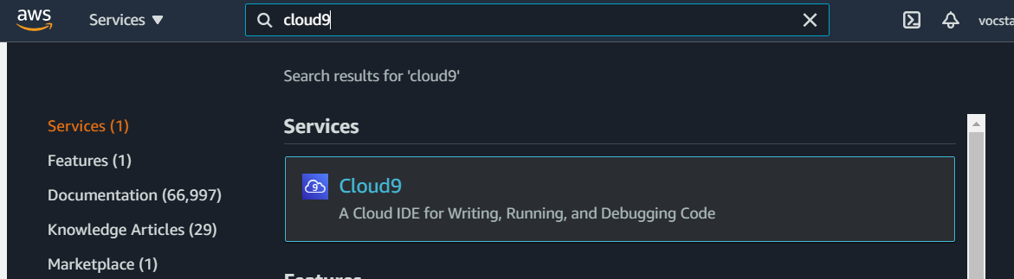

Click on Cloud9 and you should see a screen similar to the screenshot below.

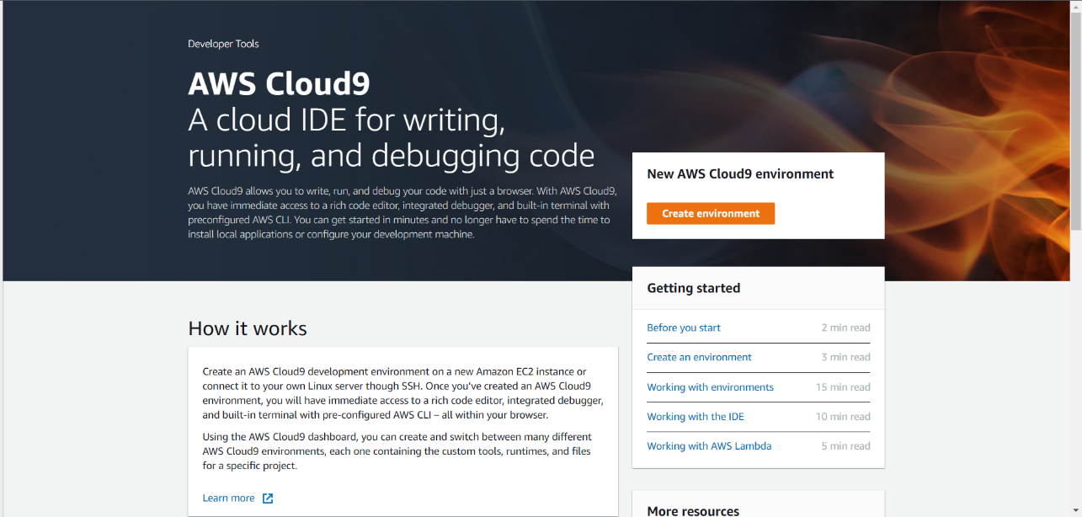

Next, click on the “Create environment” in orange below “New AWS Cloud9 environment”.

Next, we will have to set up the new Cloud9 environment by selecting a name for it and configuring the settings. Give a name for your environment and click “Next Step” as seen in the screenshot below.

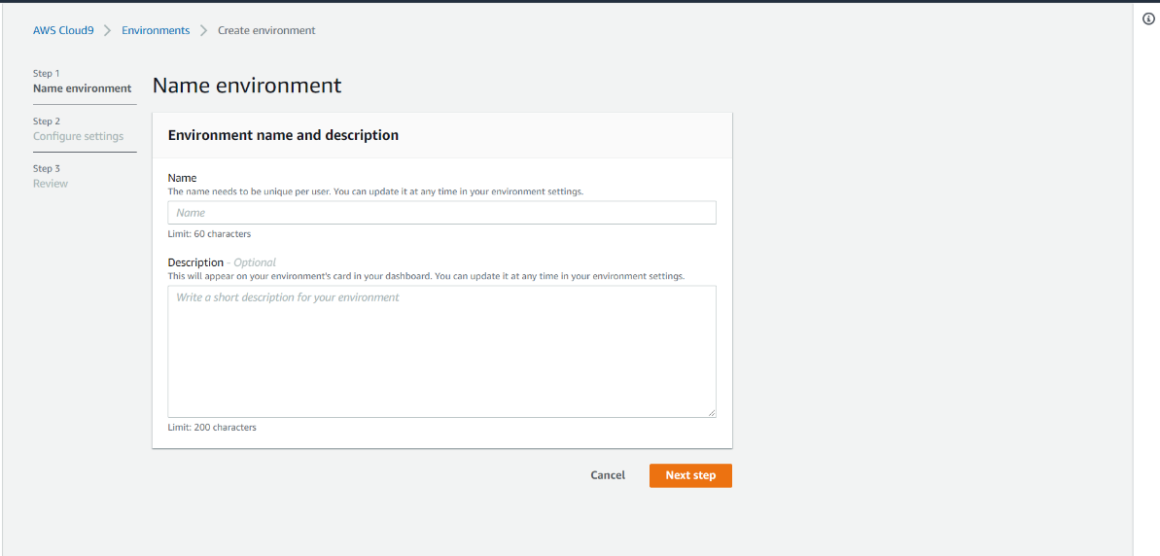

For configuration of the settings, we can leave it as the default options, which is:

1) Selecting “Select create a new EC2 instance” as Environment type.

2) Selecting “t2.micro” as instance type,

3) Selecting “Amazon Linux 2” as platform type.

Your screen should look something like this.

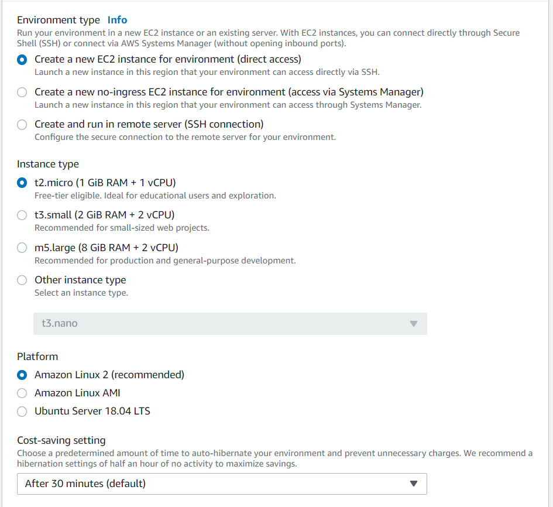

Click “Next step” after you are done configuring the settings. You should see a similar screen as shown below after clicking it.

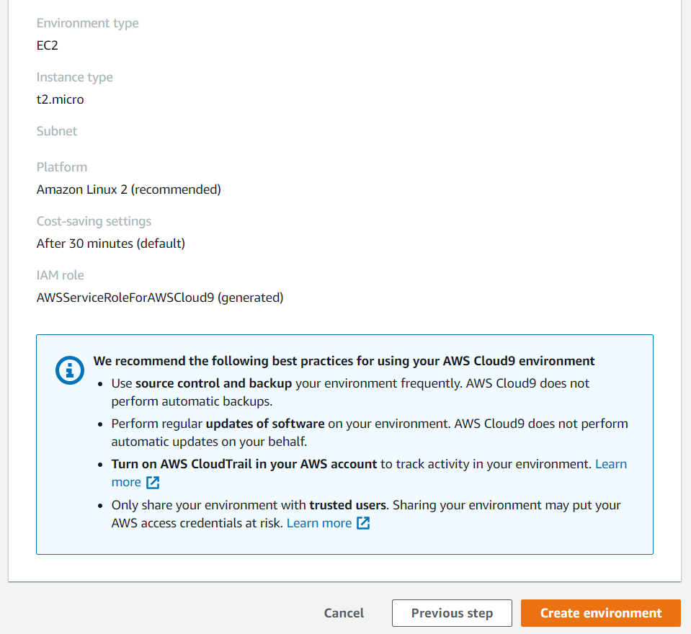

After clicking “Create environment”, you should see similar screen as shown below. This means that your Cloud9 creation was successful and will be ready upon waiting for a few minutes.

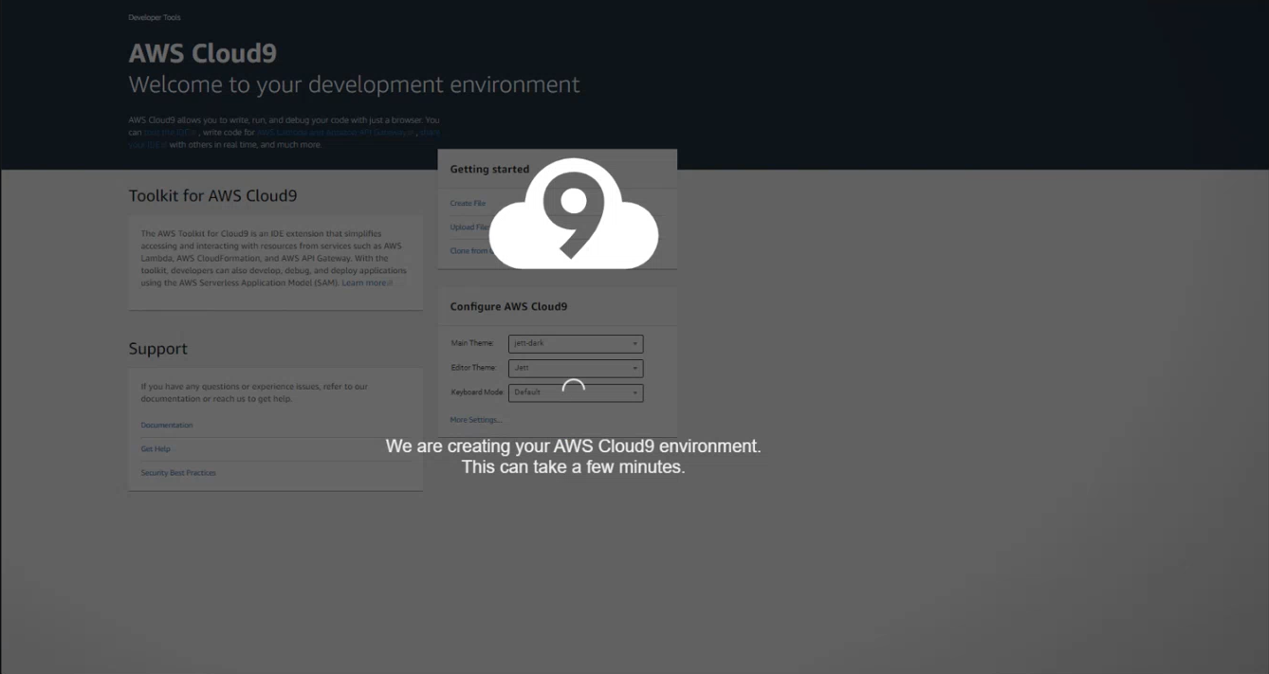

After your Cloud9 environment has been created, head over to your “Your environments” console and you should see a page that shows your Cloud9 environment. Click “Open IDE “ at the bottom right of your Cloud9 environment.

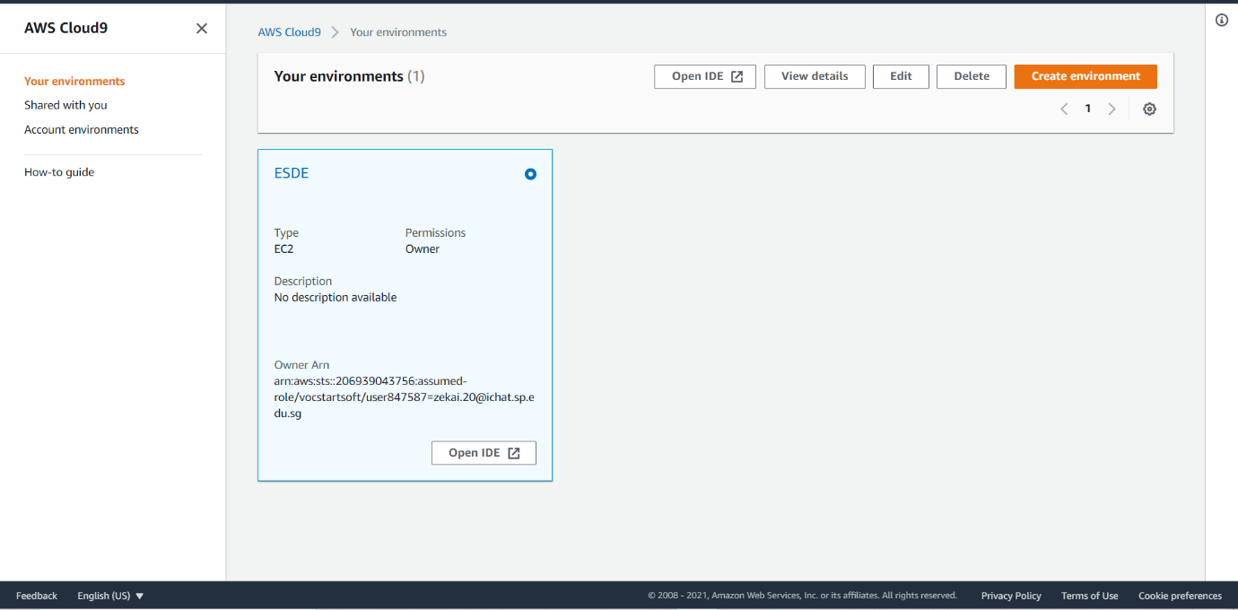

You should see a similar screen as shown below.

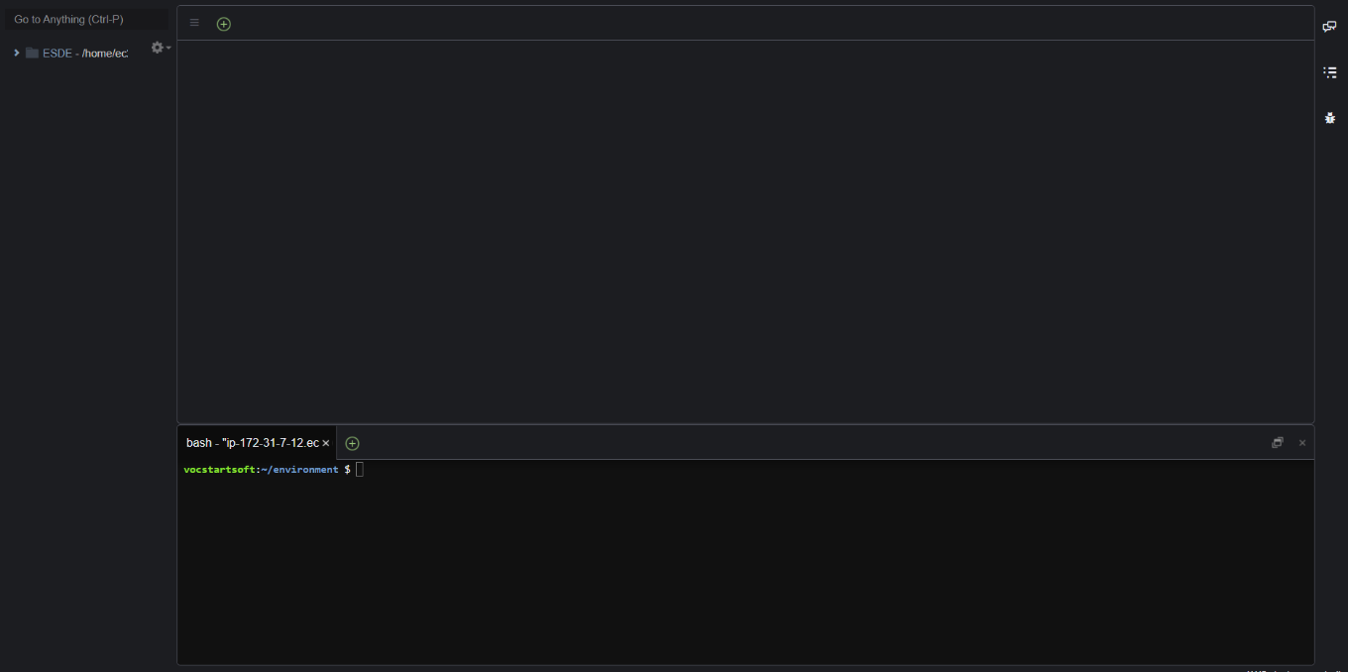

Next, under the bash terminal, enter the following command “npm install aws-sdk” as shown below.

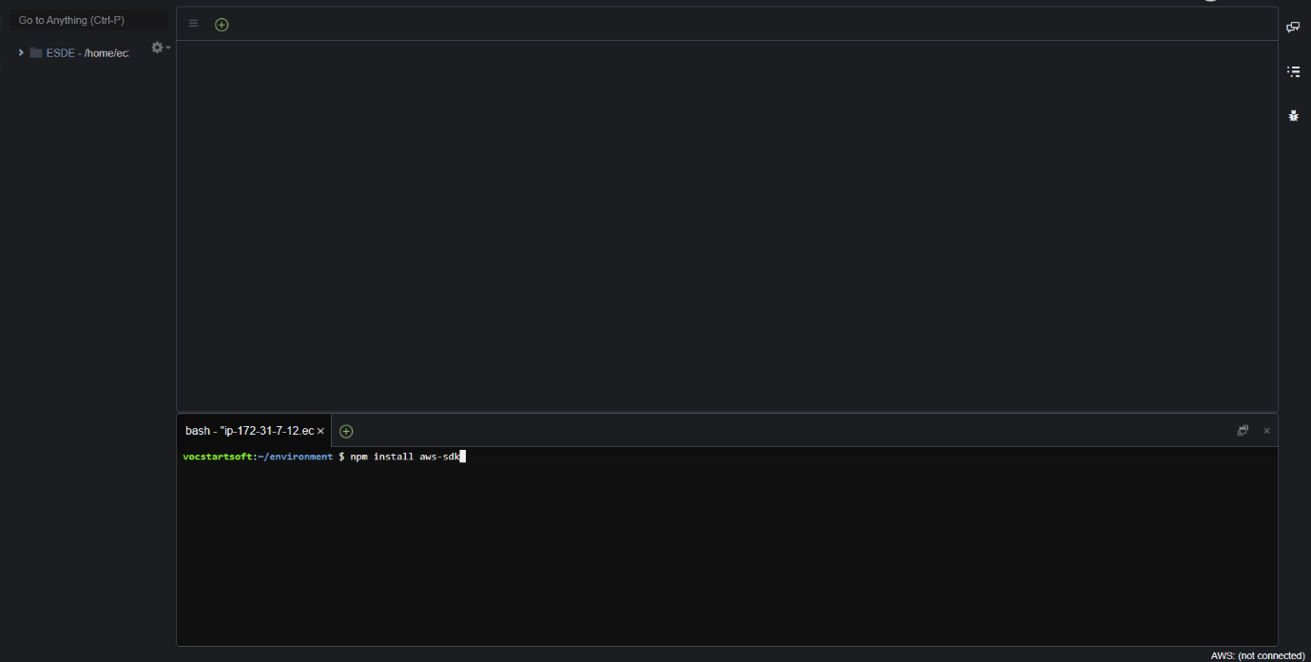

Run the following command by clicking Enter on your keyboard. This step is just installing the aws sdk. Aws sdk (software development kit) is a collection of software tools for the creation of applications and libraries that use Amazon Web Services (AWS) resources.

We have now completed configuring our Cloud9 environment. 😊

## Configuring DynamoDB

We will now be configuring our Cloud9 service on AWS. To do so, follow the steps below!

Firstly, head over to Amazon web services and search for “DynamoDB”.

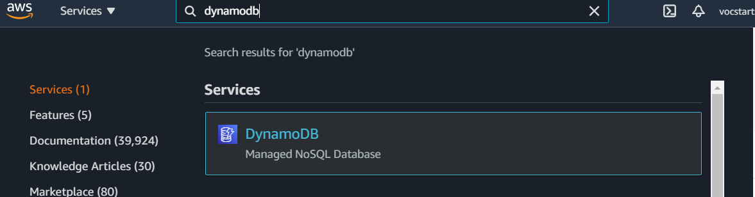

Click on DynamoDB and you should see a screen similar to the screenshot below.

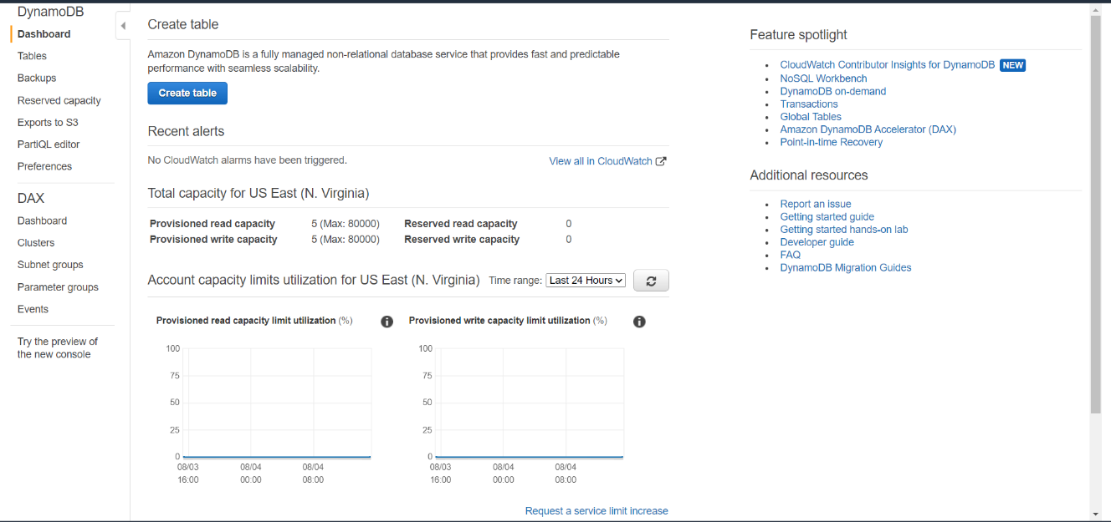

Next, click the “Create table” button in blue.

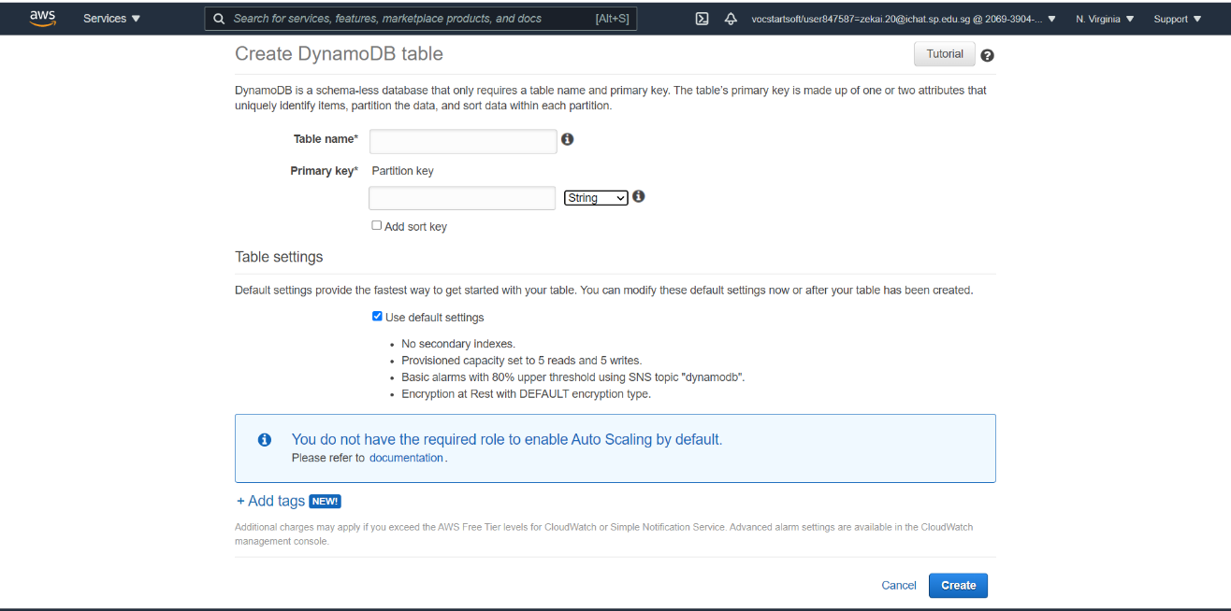

Here, we will be creating our new DynamoDB Table.

Set the Table name as “files”.

Set the Primary Key as “file_id”

Set the type beside the primary key as “Number”

Click Create.

Your DynamoDB Table should now have started to be created.

## Populating our DynamoDB Table

Next, we will be populating our DynamoDB Table. To do so, we will have to head over to our MySQL Workbench first.

Next, we will need to populate the tables. To do so, we will now need to head over to our MySQL Table. Right click each table in our old MySQL database and select “Table Data Export Wizard” as shown below



Click next and set data type to JSON and select your file path in the screen shown below. Make sure to store the Table export file in a secure place as we will require it later on.

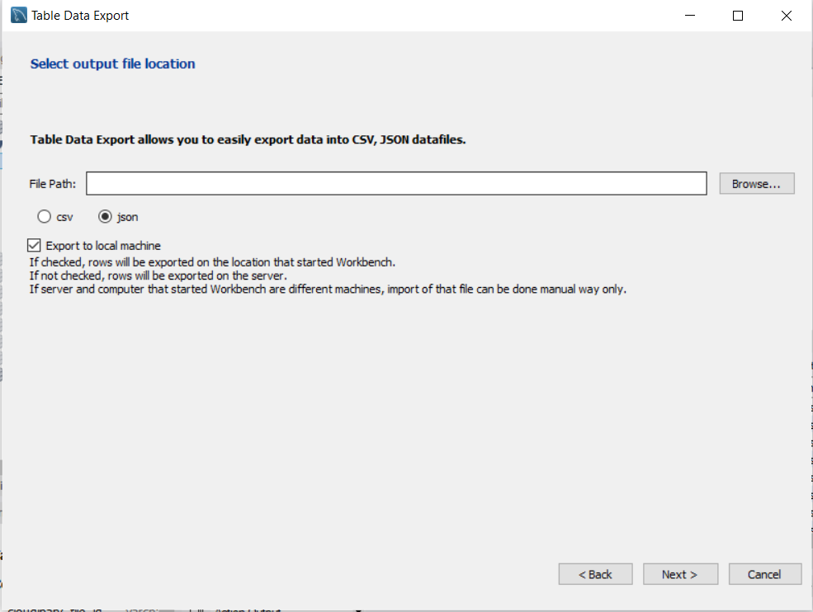

Next, we will head over to Cloud9 IDE to continue with our step of populating the DynamoDB Table.

Inside the Cloud9 IDE, we will first copy the json file from the data export wizard into our Cloud9 IDE. To do so, locate the json file on your computer and drag drop it into Cloud9 IDE. Then we will create a new javascript(js) file with the following code. The name of the javascript file does not matter, but you can name it seed.js for easy reference.

The code is as follows:

var

AWS = require("aws-sdk"),

DDB = new AWS.DynamoDB({

apiVersion: "2012-08-10",

region: "us-east-1"

}),

file_DATA_ARR = require("./file2a01.json");

function addNewItemsFromJSON(){

    console.log("All items now removed, re-seeding now");

    var

        file = {},

        file_formatted_arr = [],

        params = {};

    for(var i_int = 0; i_int < file_DATA_ARR.length; i_int += 1){

        file = {

         PutRequest: {

             Item: {

                 file_id: {

                     "N": file_DATA_ARR[i_int].file_id.toString()

                 },

                 cloudinary_file_id: {

                     "S": file_DATA_ARR[i_int].cloudinary_file_id

                 },

                 cloudinary_url: {

                     "S": file_DATA_ARR[i_int].cloudinary_url

                 },

                 design_title: {

                     "S": file_DATA_ARR[i_int].design_title

                 },

                 design_description: {

                     "S": file_DATA_ARR[i_int].design_description

                 },

                 created_by_id: {

                     "N": file_DATA_ARR[i_int].created_by_id.toString()

                 }

             }

         }

     };

     file_formatted_arr.push(file);

    }

    params = {

        RequestItems: {

            "files": file_formatted_arr.reverse()

        }

    };

    DDB.batchWriteItem(params, function(err, data){

        if(err){

            throw err;

        }

        console.log("OK");

    });

}

(function init(){

    addNewItemsFromJSON();

})();

Make sure that the variable “file_DATA_ARR” is selecting the JSON file that we copied into Cloud9. In this case, our file is called “files.json” in the example below. You can change yours depending on the name you have used for your JSON file.



Till this step, Make sure you have the following on your Cloud9 IDE

1. A JSON file containing your table data. (files.json in the screenshot below)
2. A javascript file to seed the DynamoDB Table with the codes provided above. Remember to change the file name for the “file_DATA_ARR” to your file name!! (seed_db_2a01.js in the screenshot below)

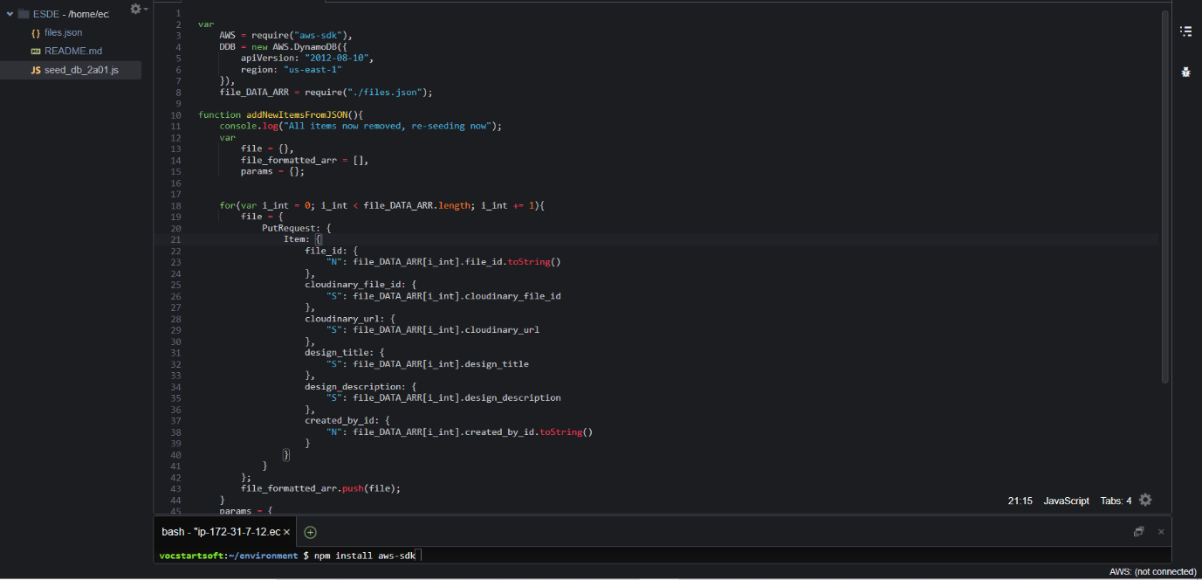

Next, run the javascript file containing the code to populate the DynamoDB Table, by clicking the “run” button on the top of the screen in green as shown below.



To verify whether your DynamoDB has been populated successfully, head back to the DynamoDB page on AWS, and go into your table (files) that you created previously and click refresh.

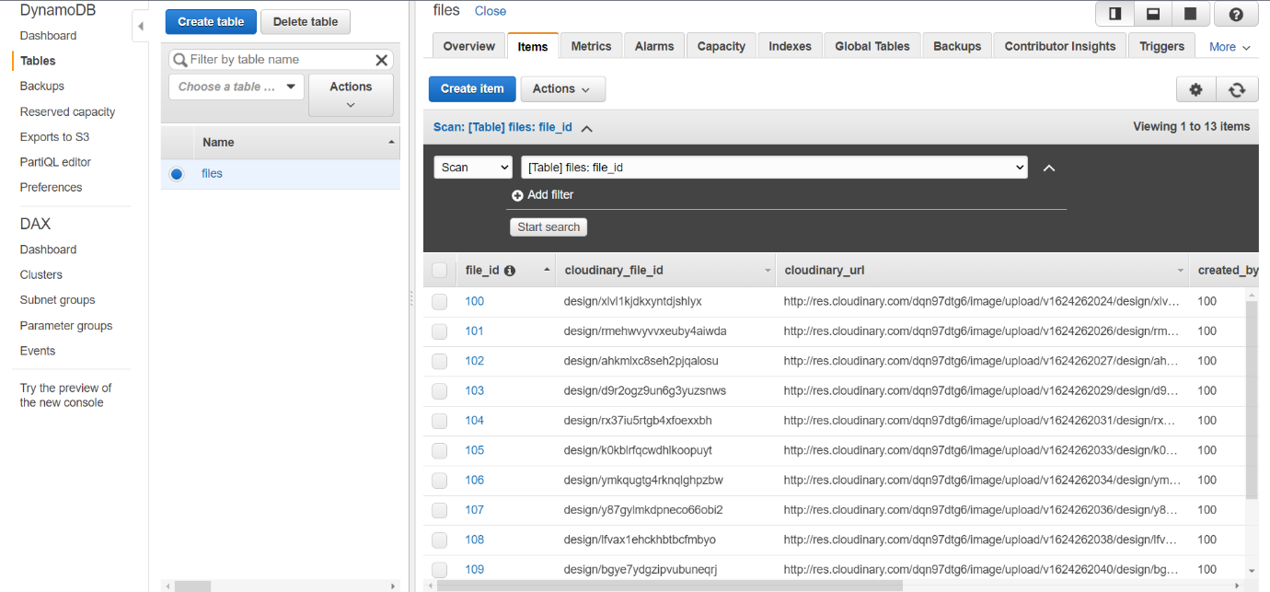

If you see a screen similar to the one above with all the data populated successfully, it means that you have completely the steps above. 😊

## Setting up Lambda Functions

Firstly, head over to Amazon web services and search for “Lambda”.

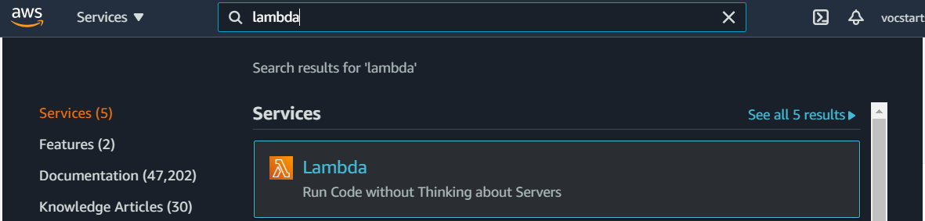

Click on Lambda and you should see a screen similar to the screenshot below.

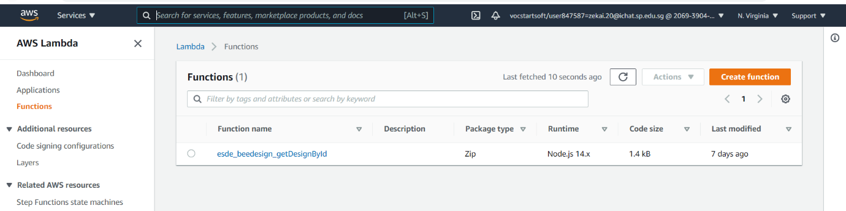

Note that you should have no functions yet and it should be an empty screen.

Click on the “Create function” in orange on the top right hand side.

Then, you should see a similar screen as shown below.

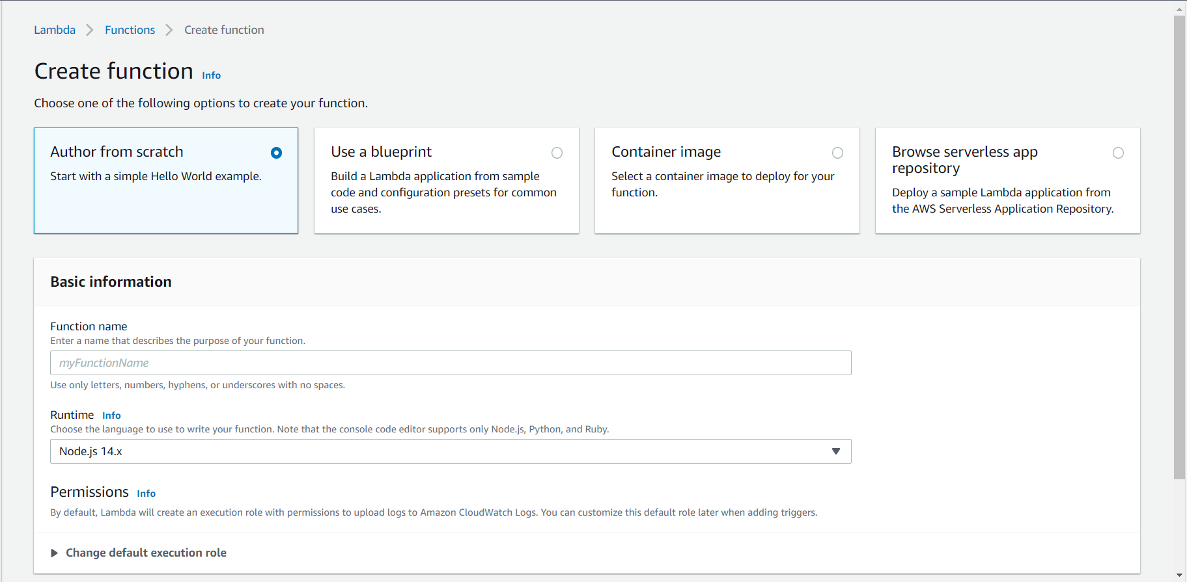

Enter the function name as “esde_beedesign_getDesignById”

Leave all other settings as default and click “create function” at the bottom right hand side.

Next, create a new folder called “dynamodb” under the “esde_beedesign_getDesignById” folder. Next, create a javascript file under dynamodb called “query_dynamodb.js”

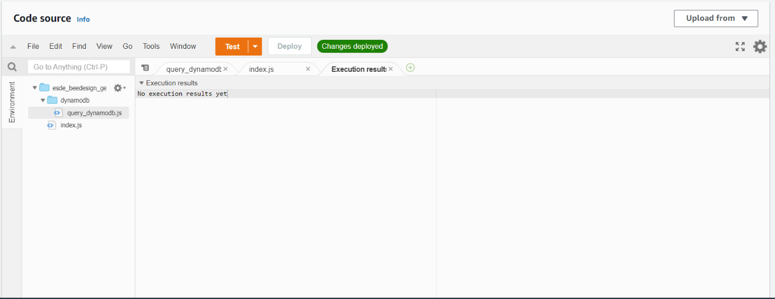

Add the following codes inside the “query_dynamodb.js” file.

var AWS = require('aws-sdk');

async function queryitems_dynamodb(region, table_name,expr_attr_values,key_cond_expr,proj_expr) {  
console.log("In the queryitems_dynamodb method...")  
var dynamodb = new AWS.DynamoDB.DocumentClient({region: region});

try{

var params = { TableName: table_name,  
ExpressionAttributeValues: expr_attr_values,  
KeyConditionExpression: key_cond_expr ,  
ProjectionExpression: proj_expr}

var items = []  
  
const results = await dynamodb.query(params).promise()  
console.log("Printing results from queryitems_dynamodb " + results)  
return results;  
  
  
}  
catch(tryerror) {  
console.log("Error occurred in dynamodb.query..")  
console.log(tryerror, tryerror.stack); // an error occurred  
}  
} //end function

module.exports = queryitems_dynamodb

Next, replace the codes in index.js (default file) with the following codes as shown below.

var dynamodbQuery = require('dynamodb/query_dynamodb');

exports.handler = async function(event, context, callback){  
if (event.fid|| (event.queryStringParameters && event.queryStringParameters.fid)) {  
if (event.fid)  
var fileId = parseInt(event.fid);  
else  
var fileId= parseInt(event.queryStringParameters.fid);  
var region = "us-east-1"  
var table_name = "files"  
var expr_attr_values = { ":fileid": fileId }  
var key_cond_expr = "file_id=:fileid"  
var proj_expr = "file_id,cloudinary_url,design_title,design_description"  
await dynamodbQuery(region, table_name,expr_attr_values,key_cond_expr,proj_expr)  
.then(data => {  
console.log("Successfully got items from dynamodb.query")  
var responseCode = 200;  
var jsonResult = {'filedata': data.Items[0]}  
let response = {  
statusCode: responseCode,  
body: JSON.stringify(jsonResult),  
headers: {  
"Access-Control-Allow-Headers" : "Content-Type,user",  
"Access-Control-Allow-Origin": "*",  
"Access-Control-Allow-Methods": "OPTIONS,POST,GET"  
}  
}  
console.log("response: " + JSON.stringify(response))  
callback(null, response);  
})  
.catch(error => {  
console.log('There has been a problem with your fetch operation: ' + error.message);  
var responseCode = 500;

let response = {  
statusCode: responseCode,  
body: JSON.stringify(error)  
}  
  
console.log("response: " + JSON.stringify(response))  
callback(null, response);  
});  
  
  
} //end if  
  
}

Next, remember to click “file” on the top left hand side, and select save all as shown below.

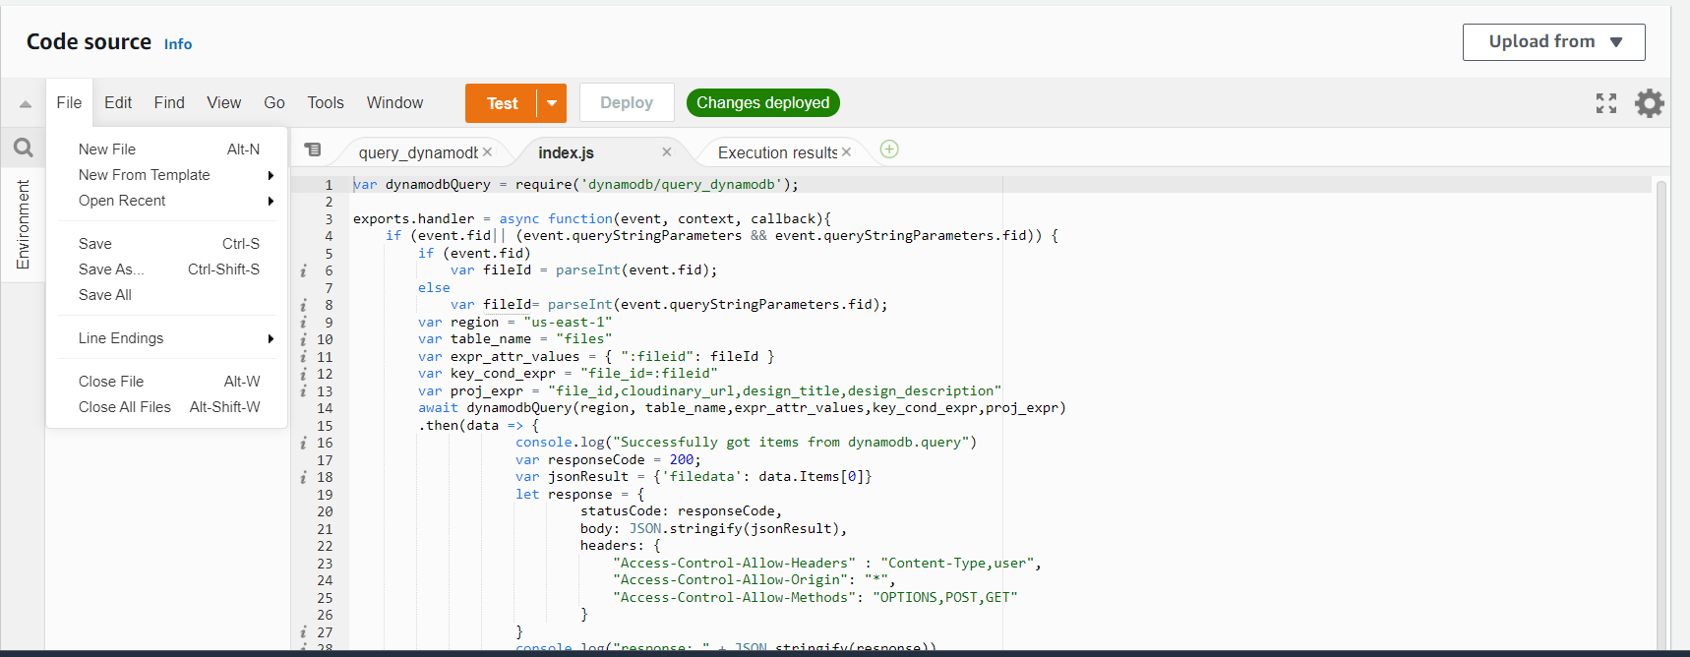

Next, click “Deploy” after you have done making your changes to the files. Once you have done that, it should show “Changes deployed” in green as shown below.

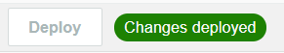

## Configuring Lambda Function

Next, we will be configuring our Lambda Function that we have created. Head over to the configuration tab 🡪 permissions and click the link in blue labelled as “Role name” as shown below.

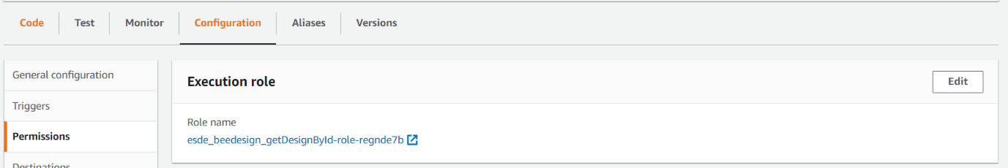

Next, you should see a similar screen below upon clicking the link.

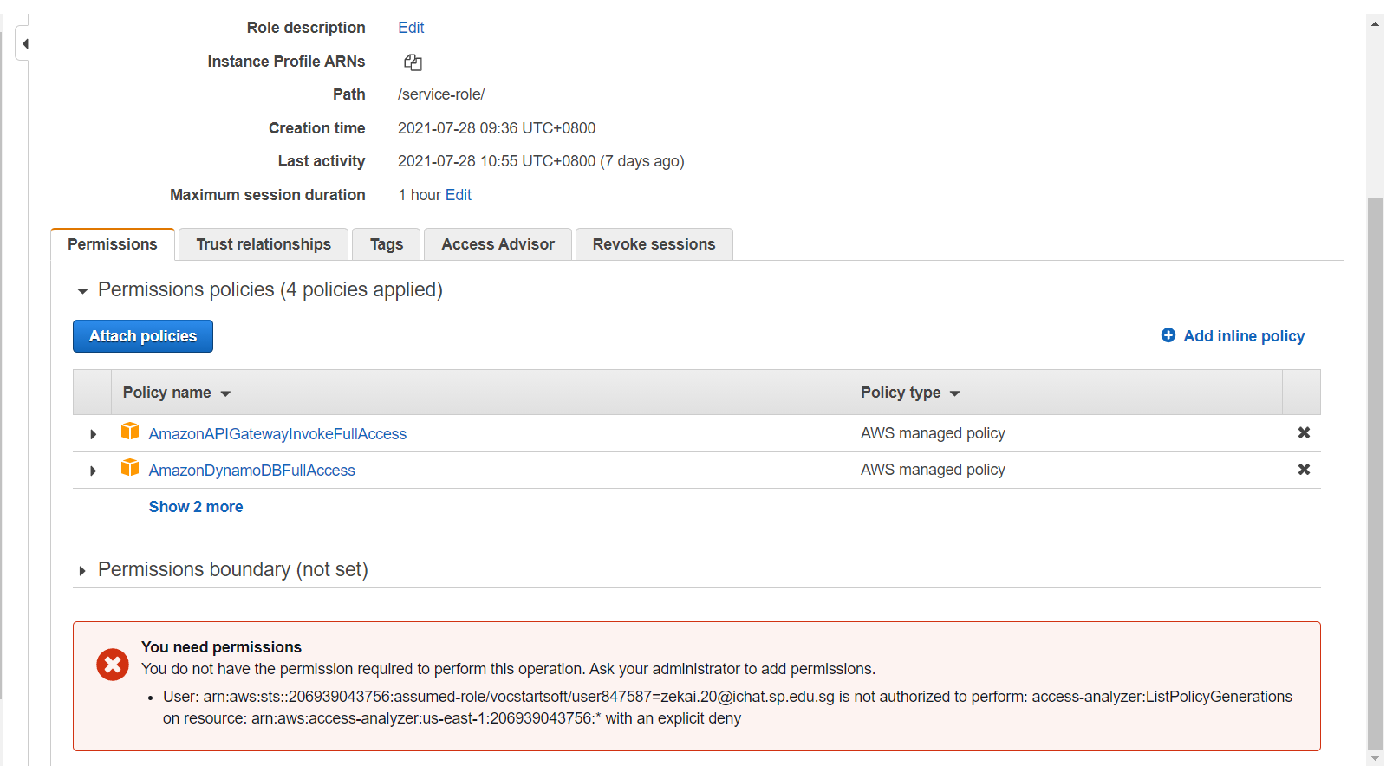

Next, click the “Attach policies’ policies button in blue as shown above.

We will need to find and attach the following policies

1. AmazonAPIGatewayInvokeFullAccess
2. AmazonDynamoDBFullAccess
3. AWSLambda_FullAccess

To do so, follow the steps below after clicking “Attach Policies”

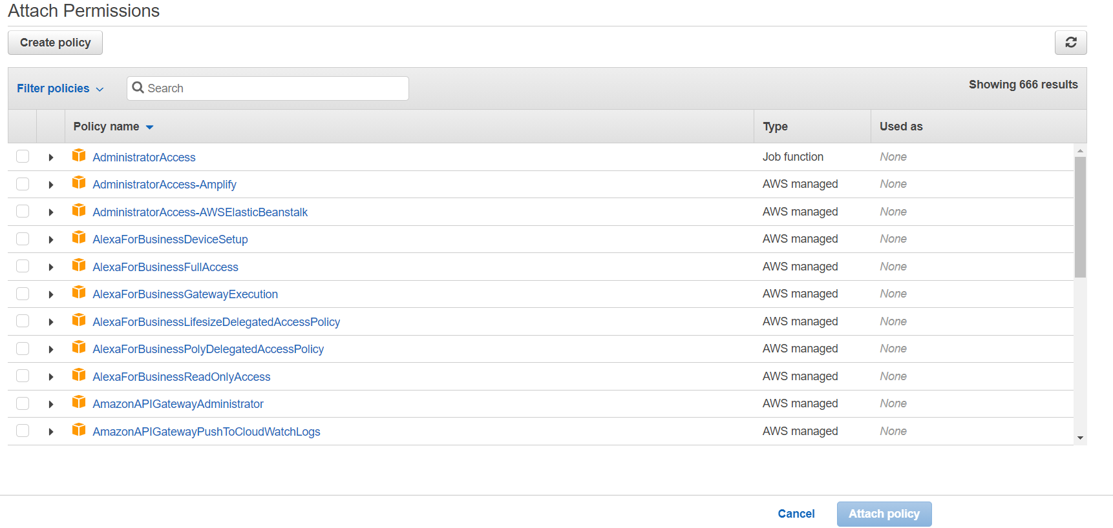

Search for the 3 policies stated above and select them by clicking the box on the left. Then click “Attach policy” after you have selected all 3 policies.

Next, head over to the “Trust relationships” tab and click “Edit trust relationship”

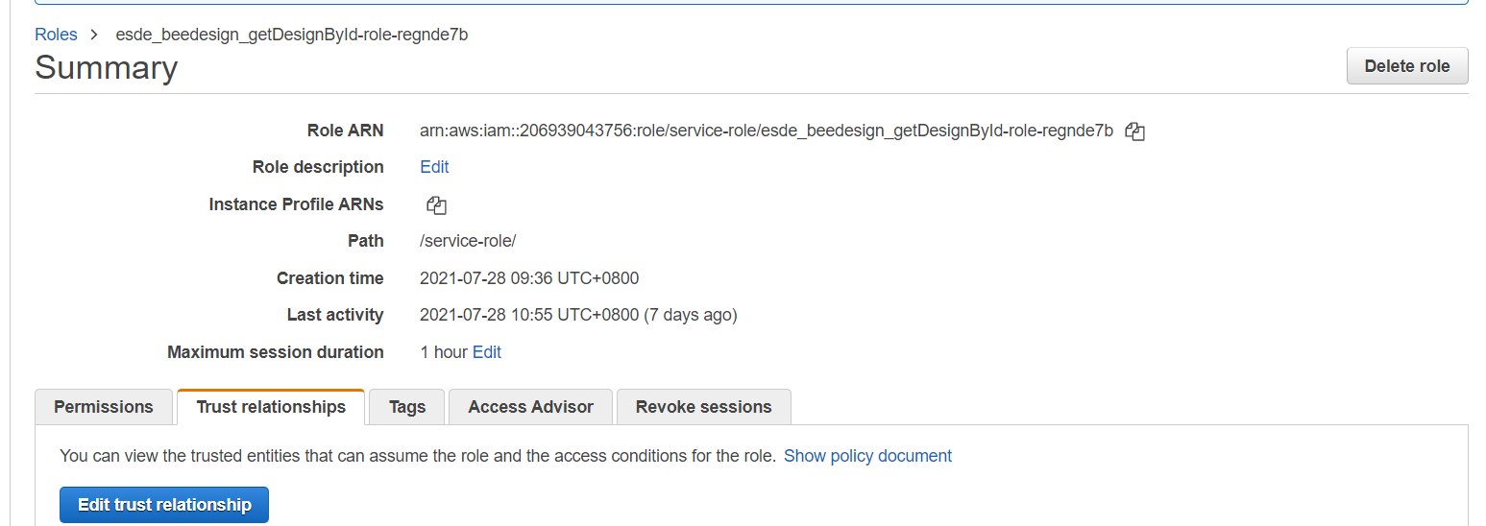

At this step, copy the Role ARN onto a notepad and store it, as we would require this when setting up the API Gateway.

Then, change the service variable to look like the screenshot below

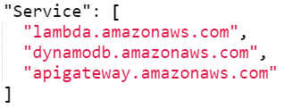

Alternatively, you can copy the following code and replace it all.

{  
"Version": "2012-10-17",  
"Statement": [  
{  
"Effect": "Allow",  
"Principal": {  
"Service": [  
"lambda.amazonaws.com",  
"dynamodb.amazonaws.com",  
"apigateway.amazonaws.com"  
]  
},  
"Action": "sts:AssumeRole"  
}  
]  
}

Next, click “Update trust policies” on the bottom right-hand side after replacing the code.

We have now successfully configured the permissions for our Lambda Function.

## Testing our Lambda Function

Since we have configured our Lambda function, it is time for us to now do a test to verify if it is working properly!

To do so, head over to the Lambda console page.

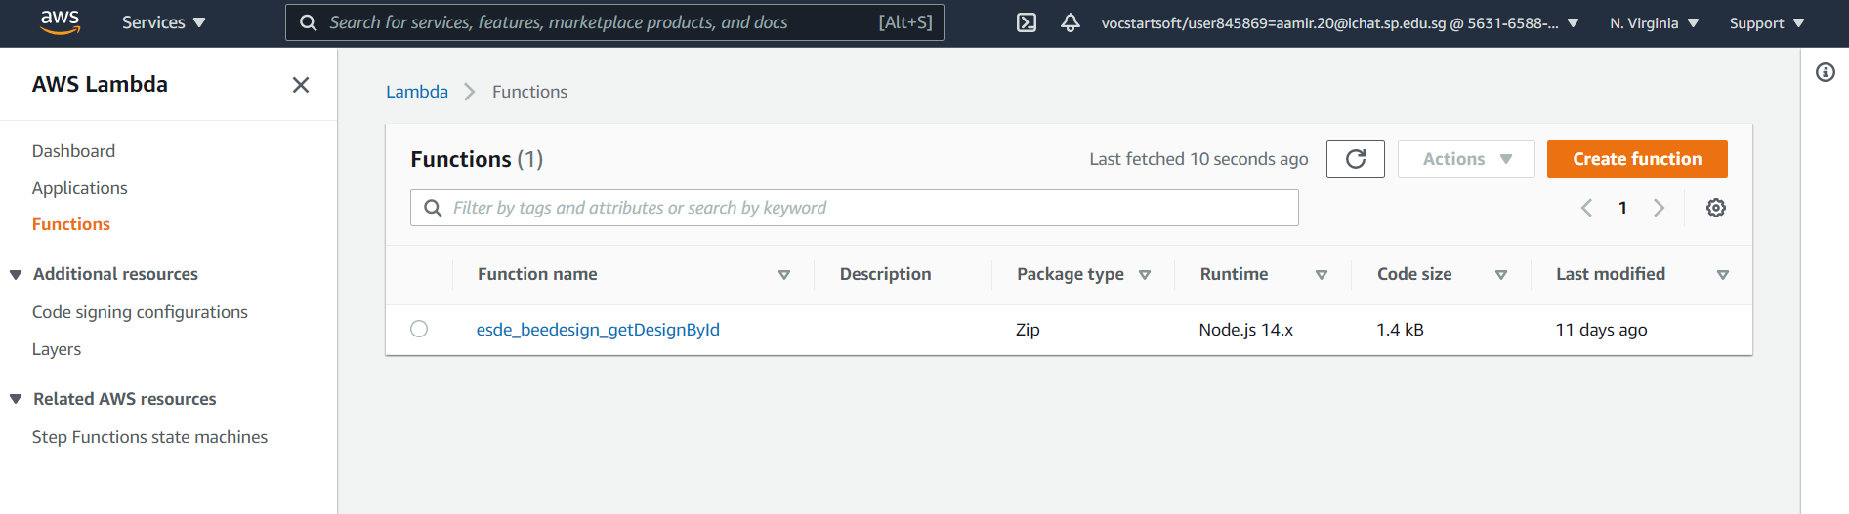

Click on the function we just created. In this case, “esde_beedesign_getDesignById”

You should then see a similar page as shown below

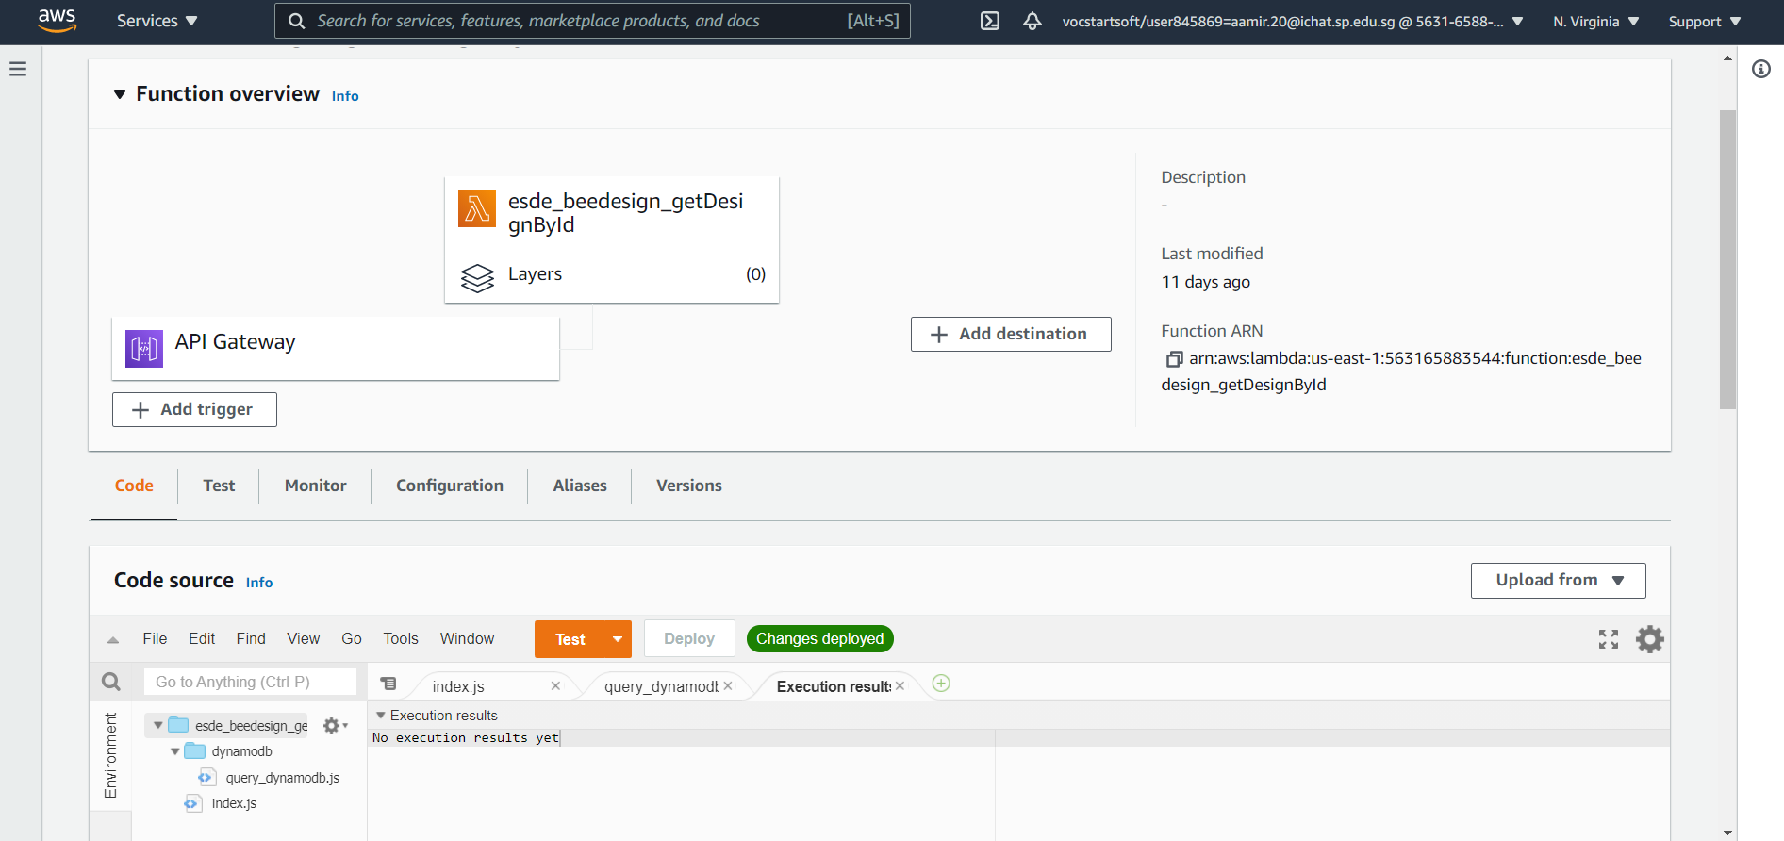

Click on the arrowhead pointing down right beside the orange “Test” button.

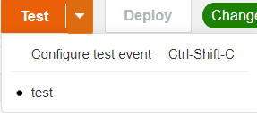

Then, click on “Configure test event”

You should then see a similar screen as shown below

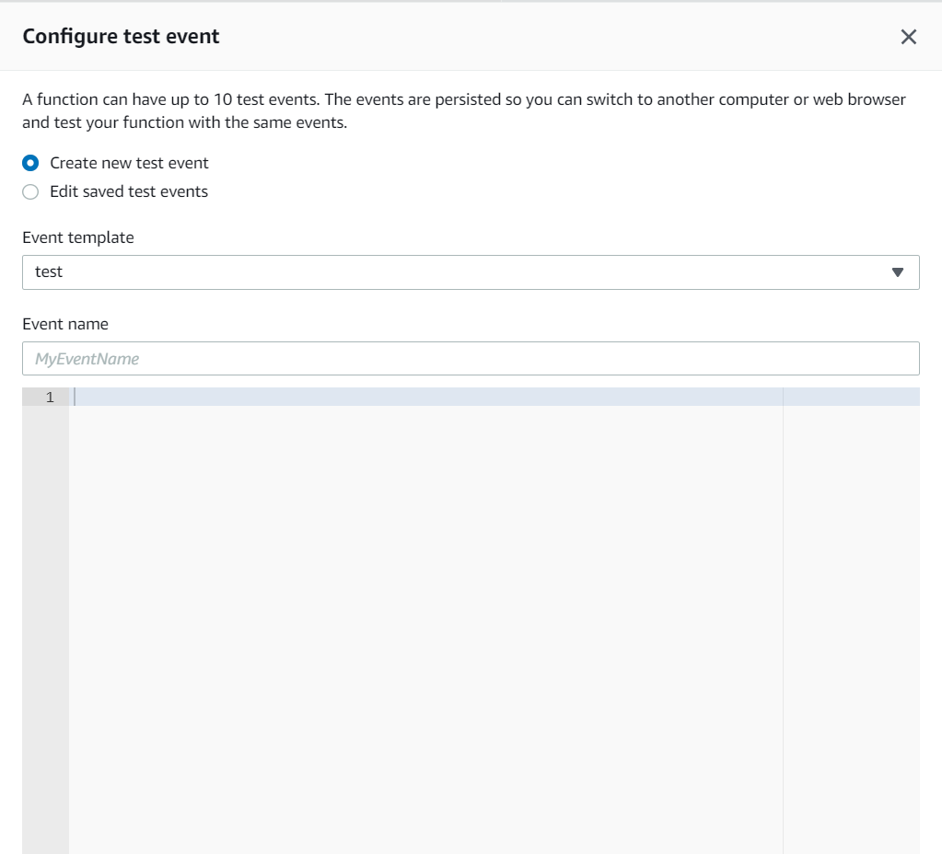

For the radio button, click on the “Create new test event” button

You can enter any name for the “Event name”. I am going to call it Test

Next, under the blank space, copy and paste the following code

{

"fid": "100"

}

This is going to pass in the parameters as fid 100, which is going to fetch the design with id 100. After you have configured your test event, click the “Create” button on the bottom right

Then, click you should be back on the page as shown below.

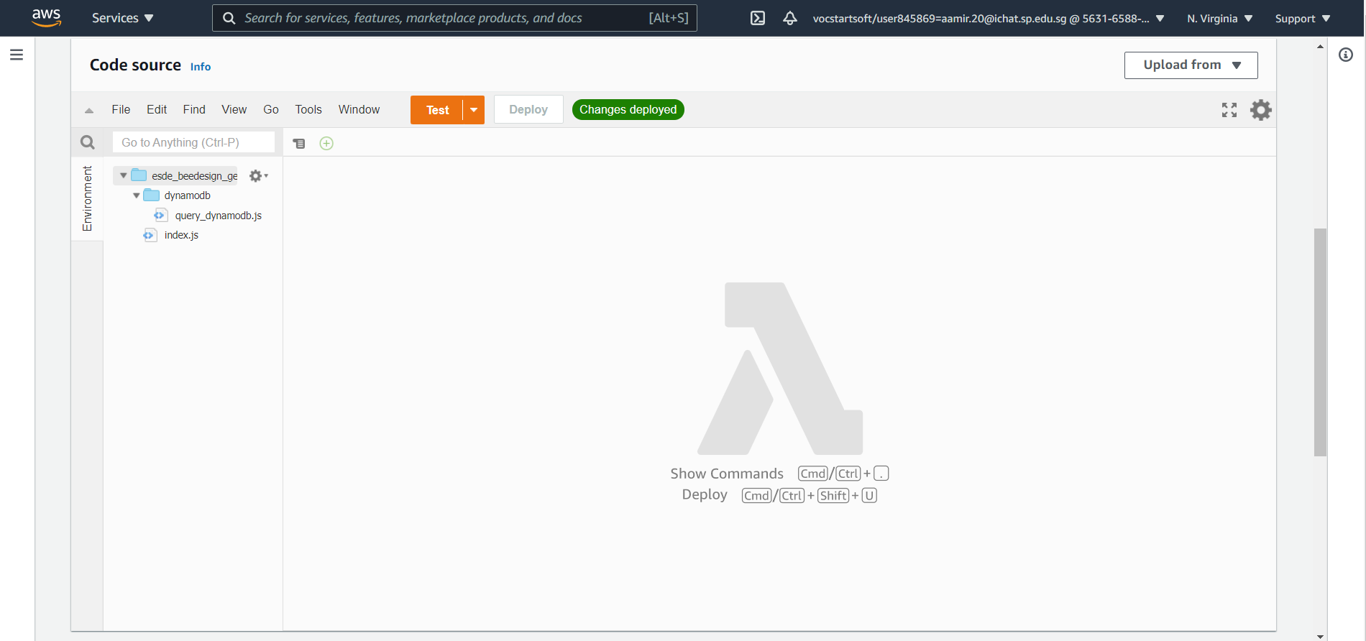

Click the “Test” button in orange and observe the results

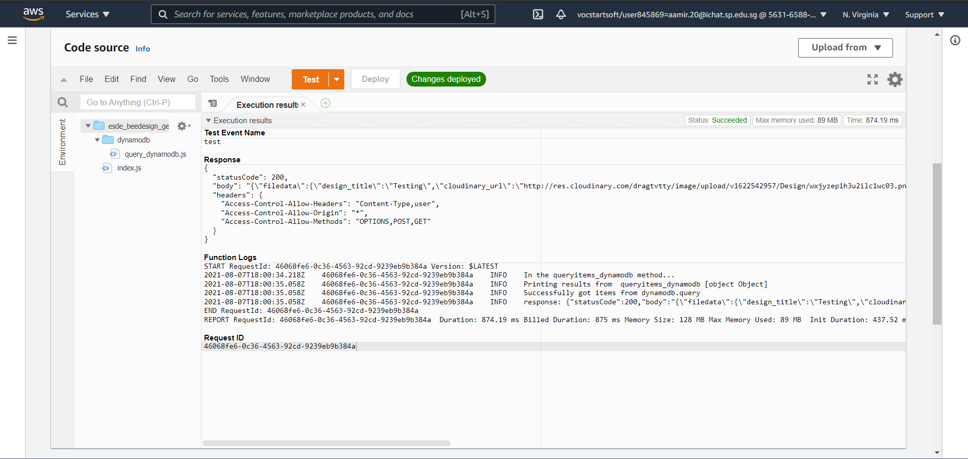

As shown in the screenshot above, we are able to get the details for design with id 100, which verifies that our Lambda function is working and will not cause any issues when testing our web application!

You can only do further testing by creating multiple tests, by just changing the file id and observing whether you are retrieving the correct data

## Setting up API Gateway

We will now be setting up our API Gateway service on AWS. To do so, follow the steps below!

Firstly, head over to Amazon web services and search for “Api Gateway”.

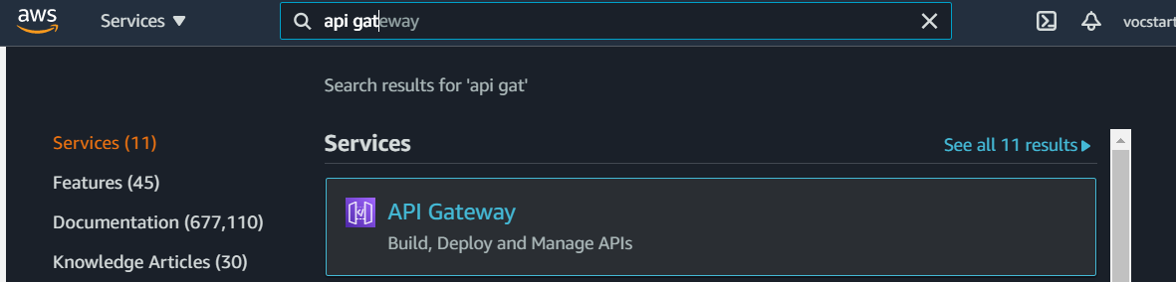

Click on API Gateway and scroll down until you see “REST API” and select Build

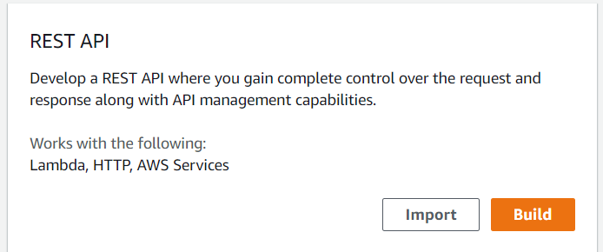

Next, you should see a similar screen as shown below

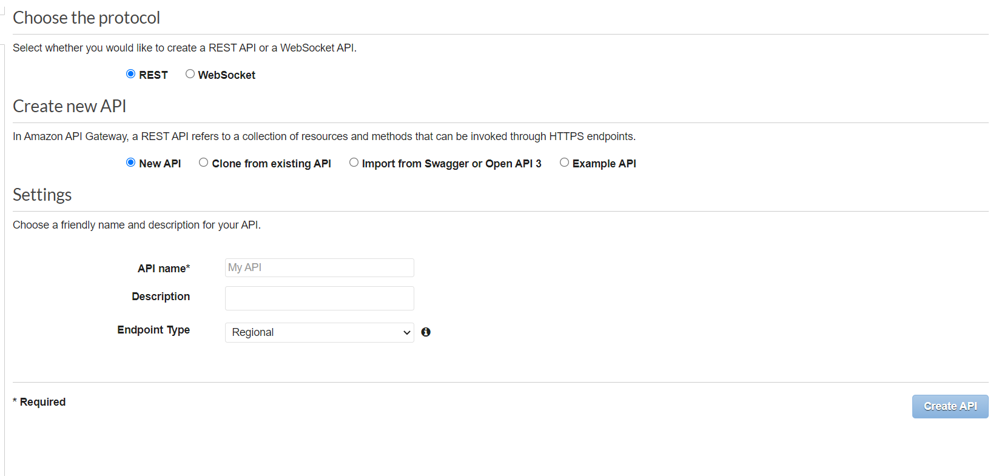

Enter the API name as “esde_beedesign_api”

Leave all the other options as default as shown above.

Then, click the “Create API” button in blue.

Next, after doing so, you should see a similar screen as shown below.

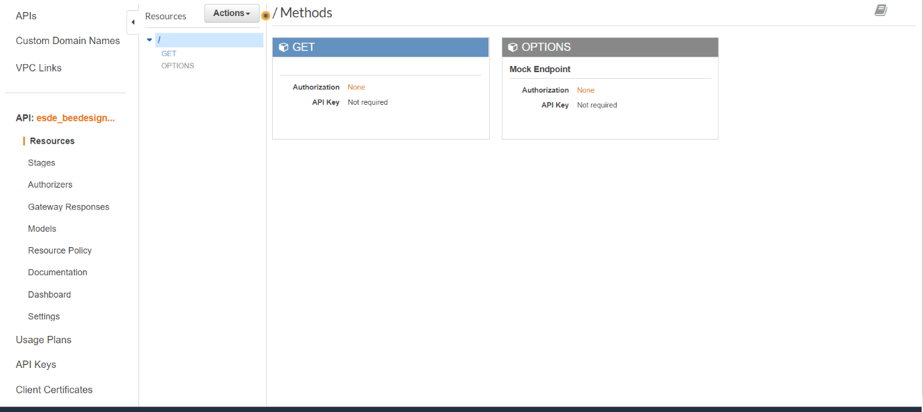

Next, Select Actions 🡪 Create method

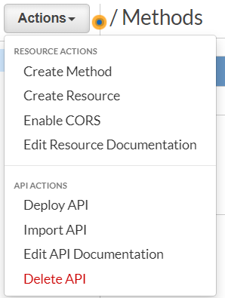

Next, select GET

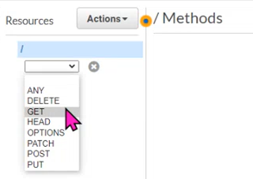

Then, click the tick beside the GET

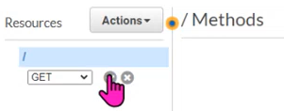

Upon clicking the tick, you should see a similar screen as shown below

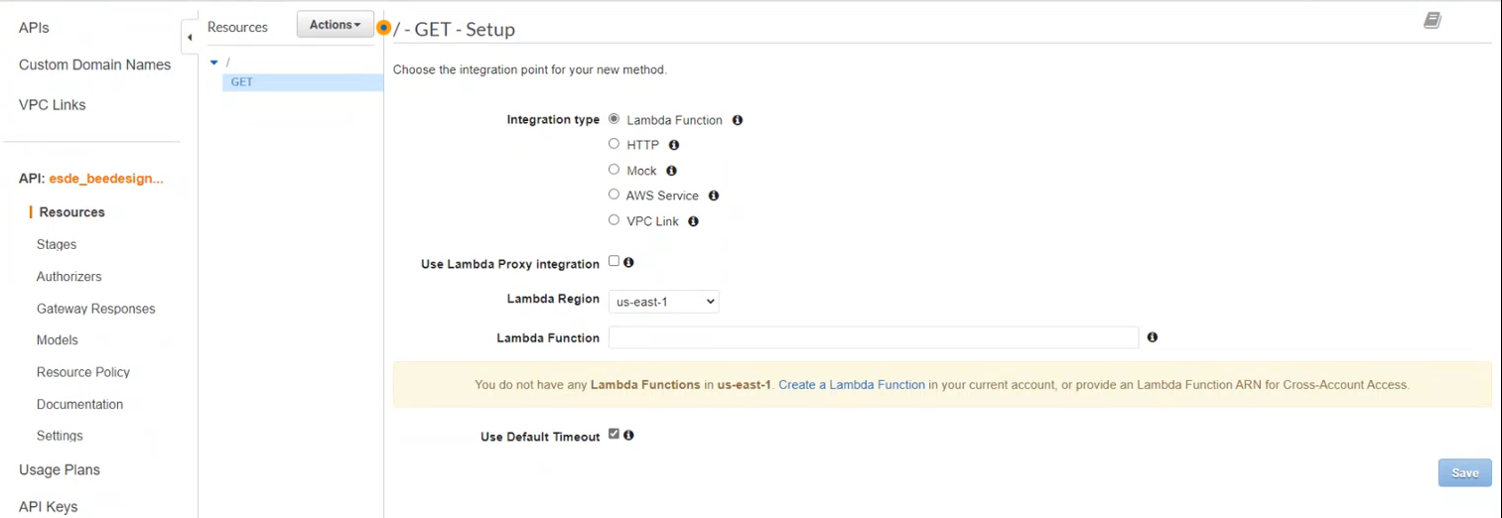

Next select the Integration type as “Lambda Function”

Check the tickbox for “Use Lambda Proxy Integration”

Select the Lambda Region as “us-east-1”

Select the Lambda Function as the lambda function we created previously. In this case, it will be “esde_beedesign_getDesignbyId”.

Your screen should look something similar to the screenshot below.

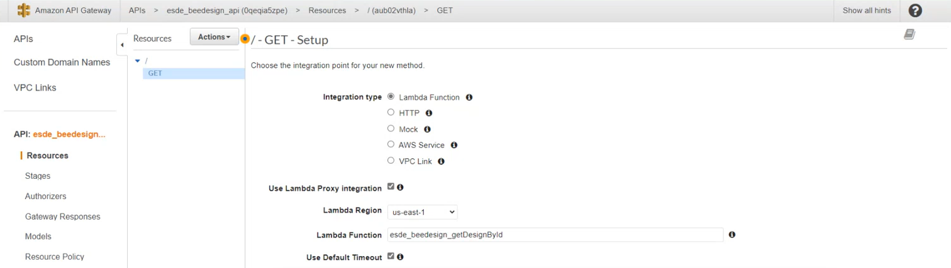

Next, you can click the “save” button in blue on the bottom right hand side.

You should then see a popup as shown below

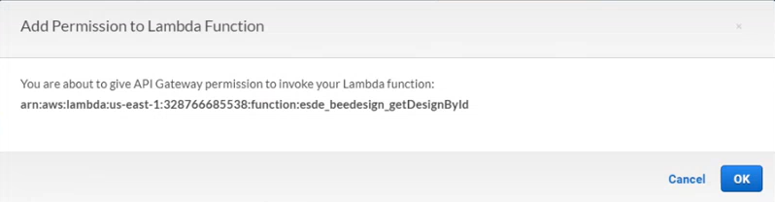

Click “OK”

After clicking the “OK” button, you should see a similar screen as shown below.

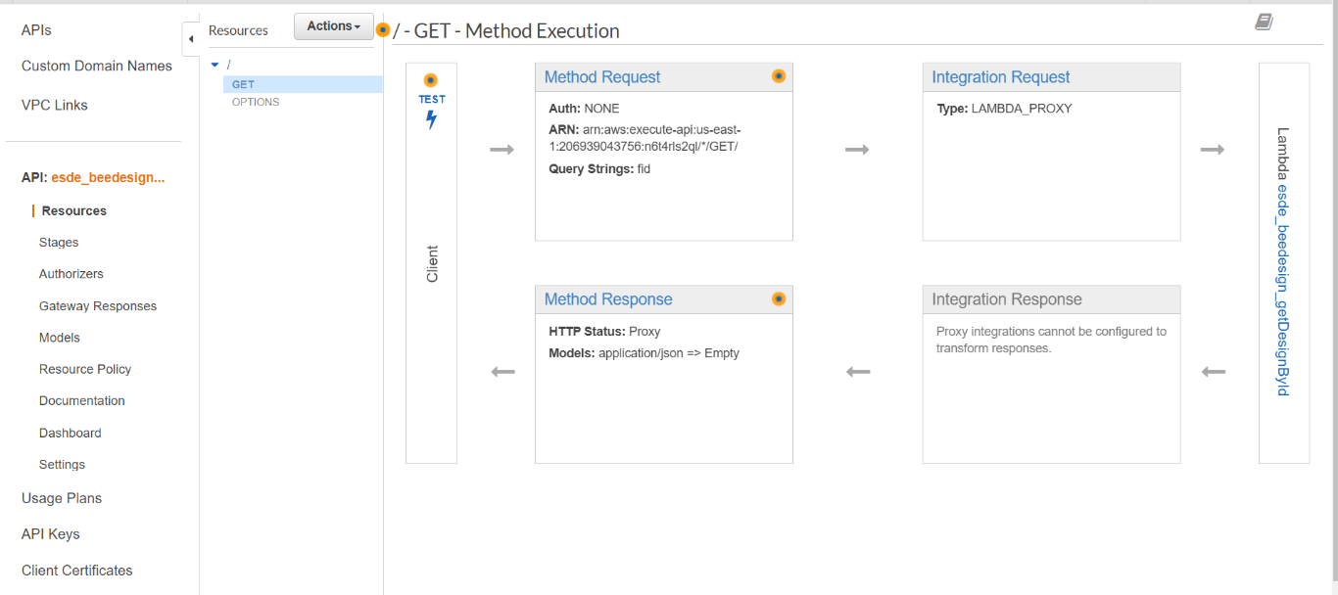

As you can see, there are four Method Execution. Select Integration Response and you should see a similar screen as shown below

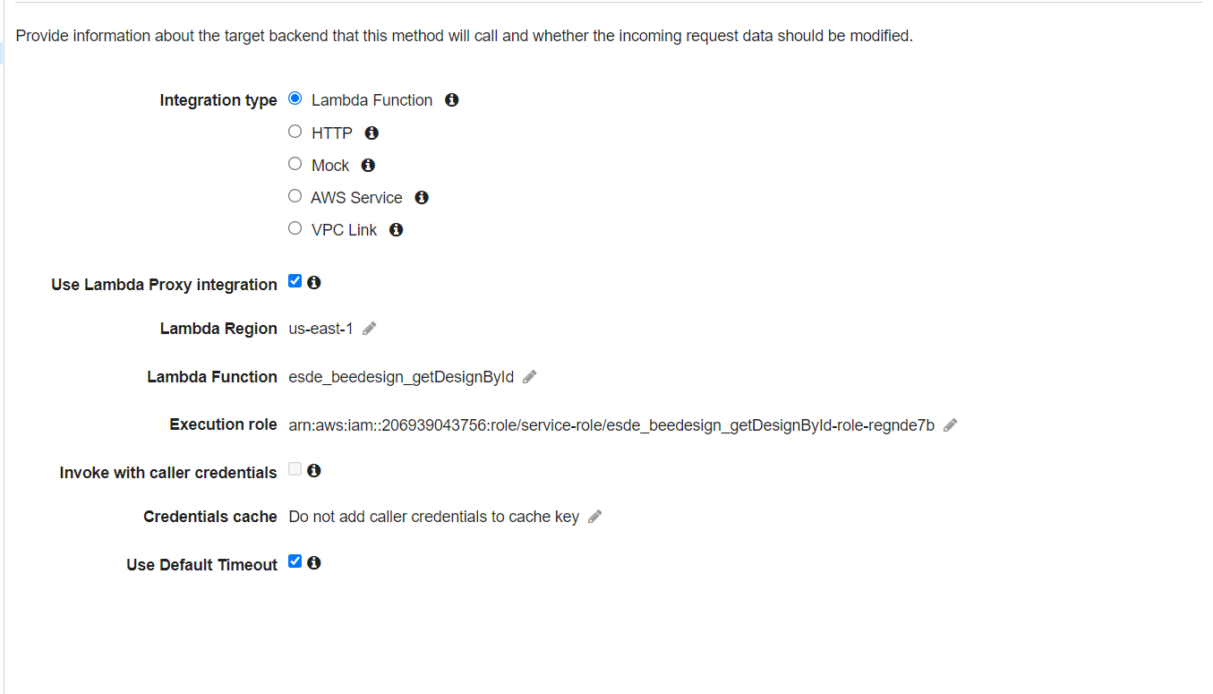

Next, click the pencil icon beside the Execution role, and paste the Role ARN that we previously copied when configuring our Lambda function.



Click the tick mark beside it after pasting the Role ARN.

Next, you will need to go to actions and Enable CORS

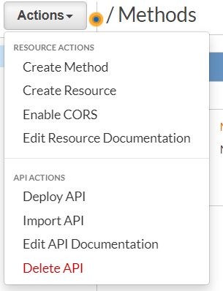

After clicking, you should see a similar screen as shown below

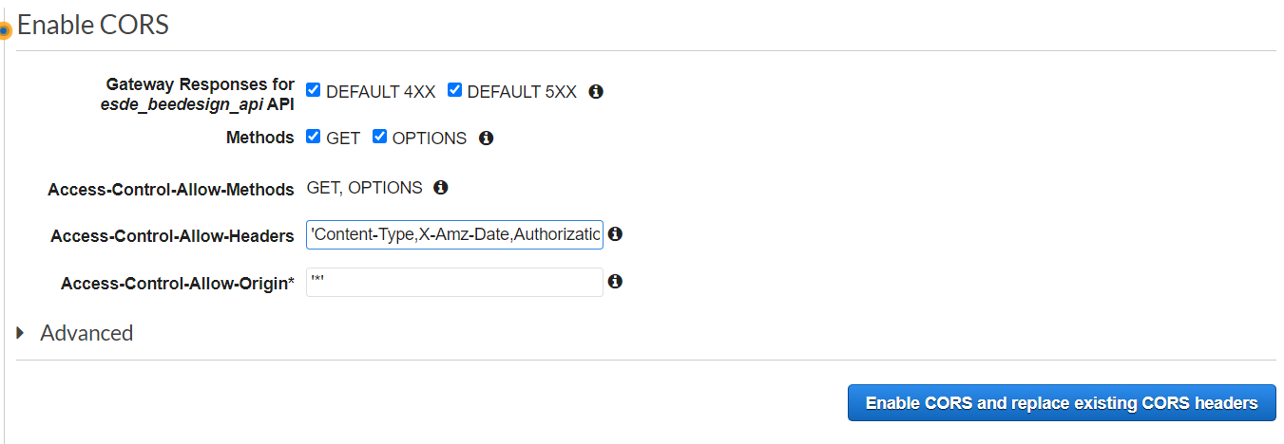

Make sure to checkmark the DEFAULT 4XX and DEFAULT 5XX, and add “,user” at the end of “Access-Control-Allow-Headers” within the quotes.

You can leave the rest as default setting.

Then click the “Enable CORS and replace existing CORS headers” button in blue.

You should see a similar screen as shown below upon clicking the button.

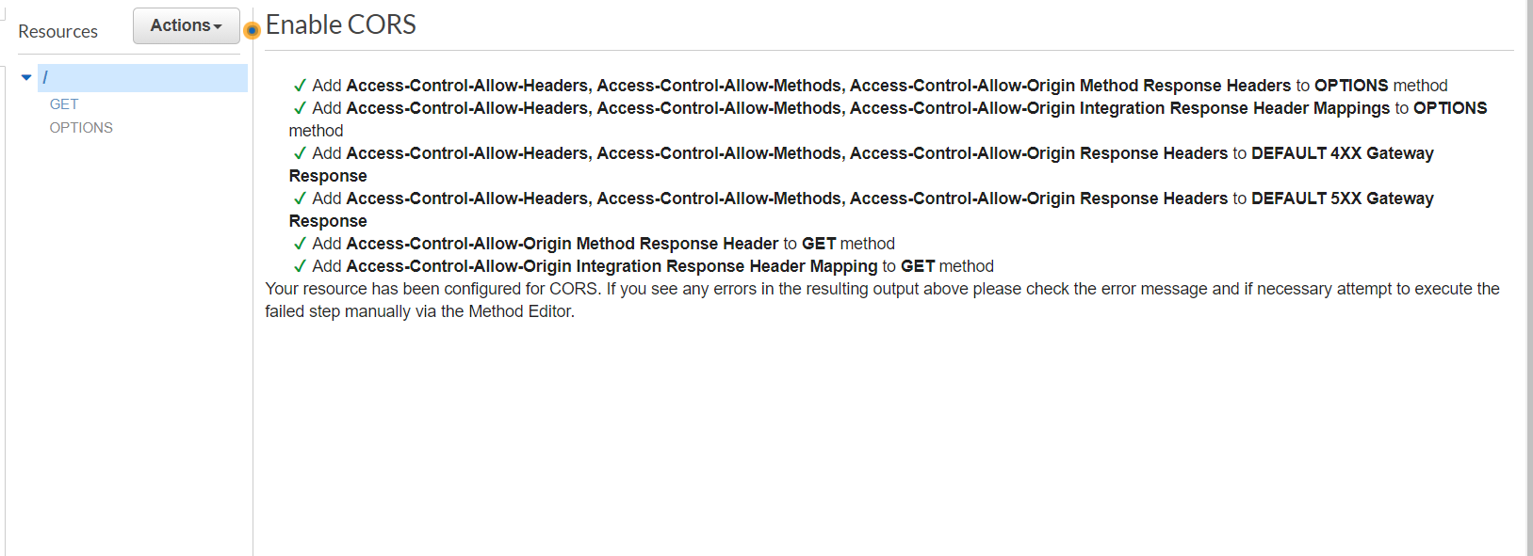

Then, go back to Actions and select Deploy API

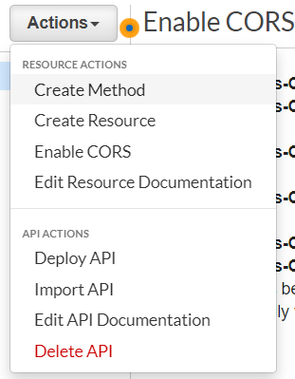

Next, you should see a screen as shown below

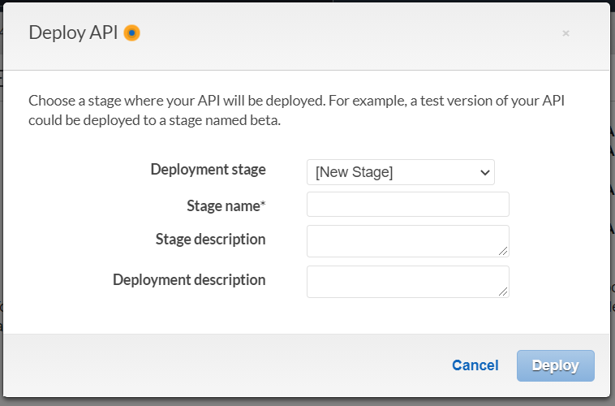

Select Deployment stage as “ [New Stage] “

Select Stage name as test

Click “Deploy”

Next, go back to the Method Execution page as shown below

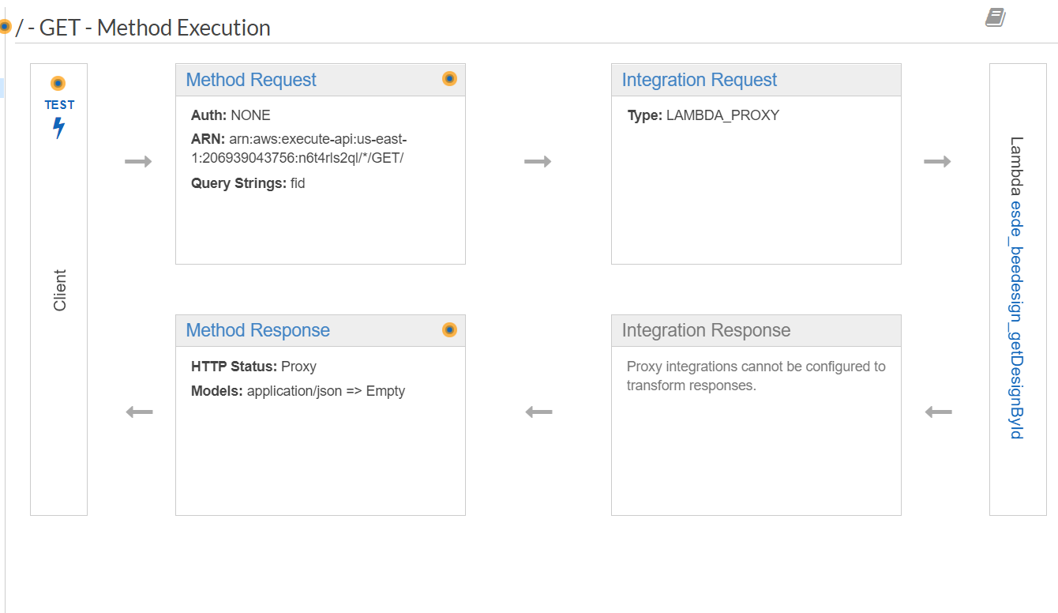

Select “Method Request”.

You should see a similar screen as shown below

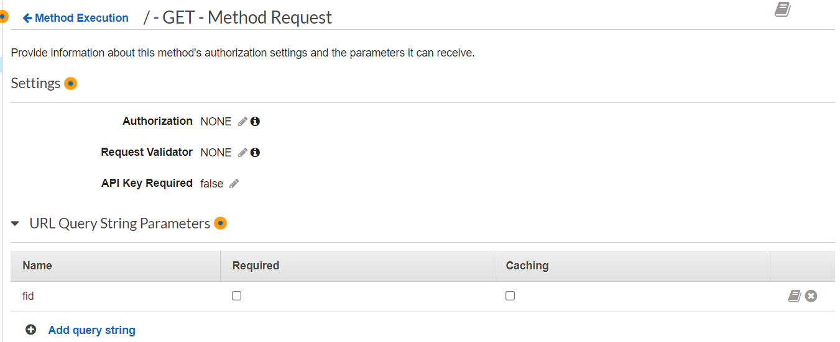

Expand the “URL Query String Parameters” menu and click the “Add query string” button.



Set the myQueryString as “fid” and click the tick.

Next, locate to the “Stages” tab from the menu on the left.

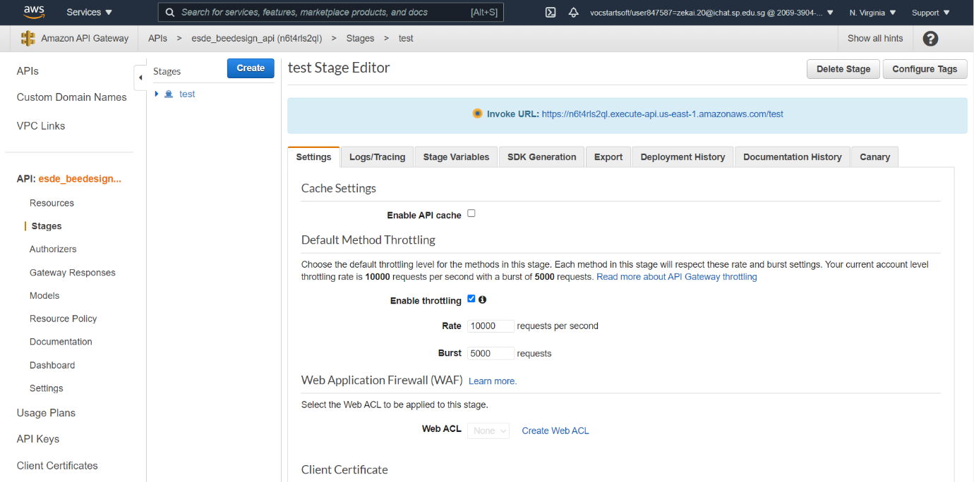

Next, copy the URL under the “Invoke URL” which is highlighted in light blue.

Then, we will need to head over to our WinSCP frontend 🡪 public 🡪 js 🡪 update_design.js

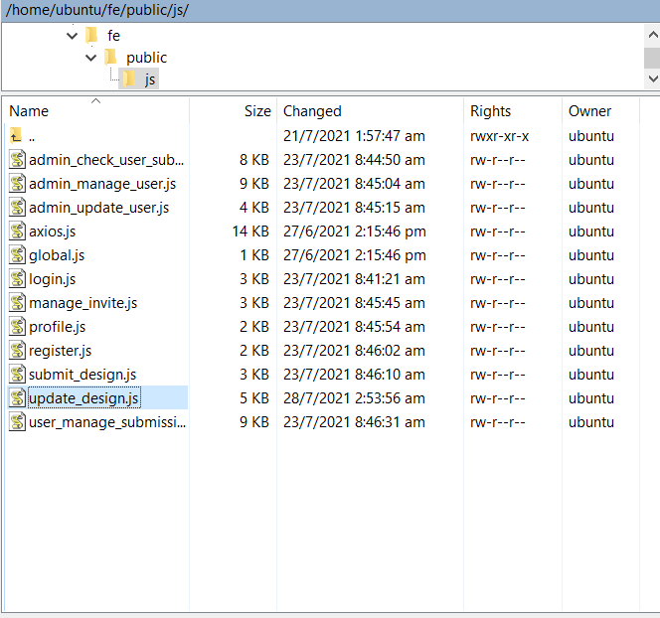

Open up the update_design.js file

Then, locate to the “getOneData( )” function.

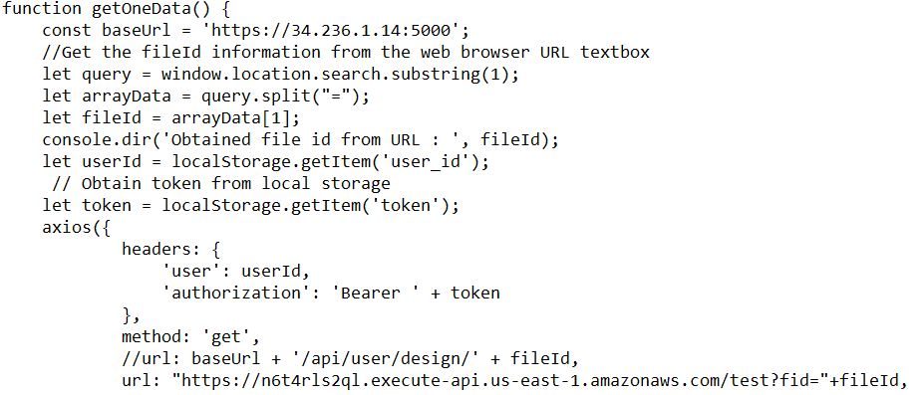



Replace the url with the URL we previously copied and add ?fid=”+fileId as shown above. When this function is triggered in the frontend, it will send the relevant data to our lambda function instead of fetching it from the backend. The lambda function will then fetch the relevant data from our DynamoDB.

We have completed the configuration of the API Gateway.

## Testing our API Gateway

Since we have finished configuring our API Gateway, we will now test and verify whether it is working!

To do so, head over to the API Gateway console page as shown below.

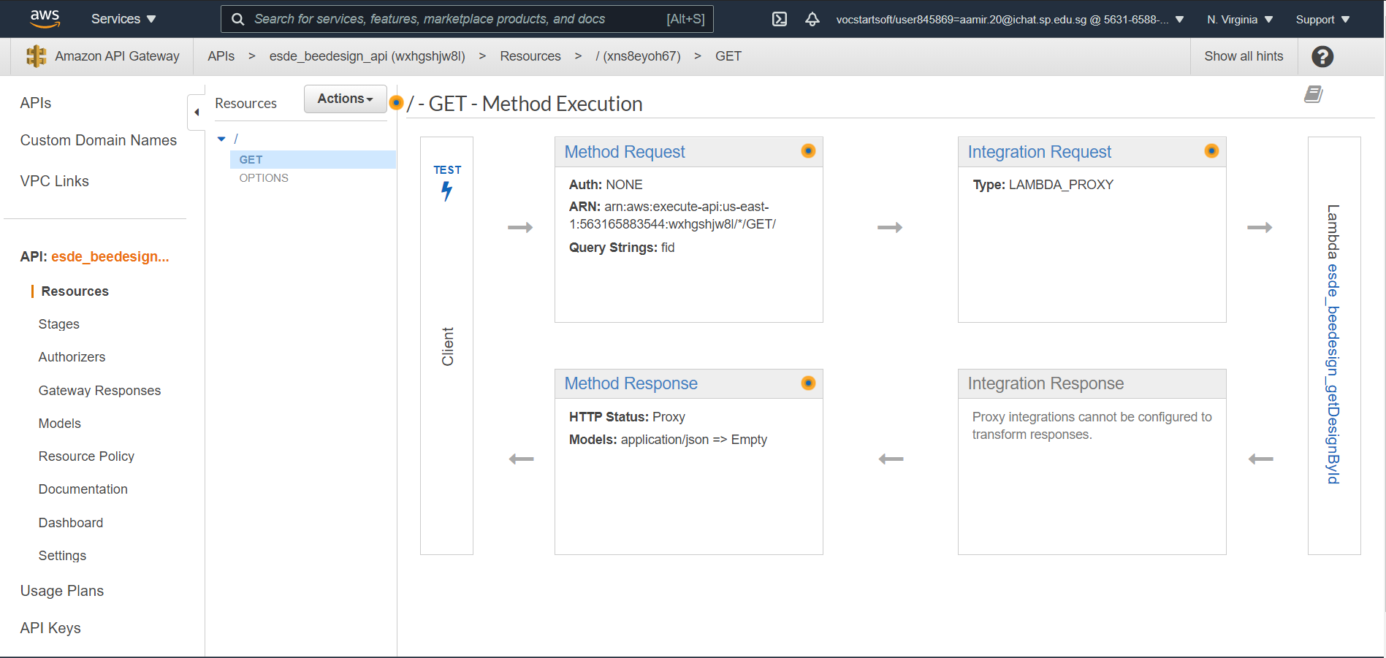

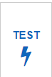On this page, you would be able to see the “TEST” Button with the lightning icon below it. Click it.

Next, you should see a similar page as shown below 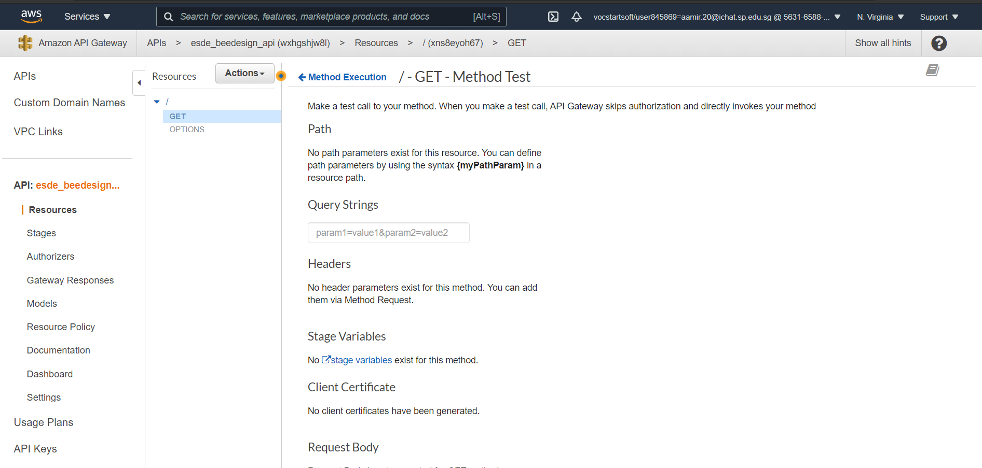

Under the “Query Strings” , pass in the following value “fid=100”. By doing so, we are trying to do a GET of our design with id 100.

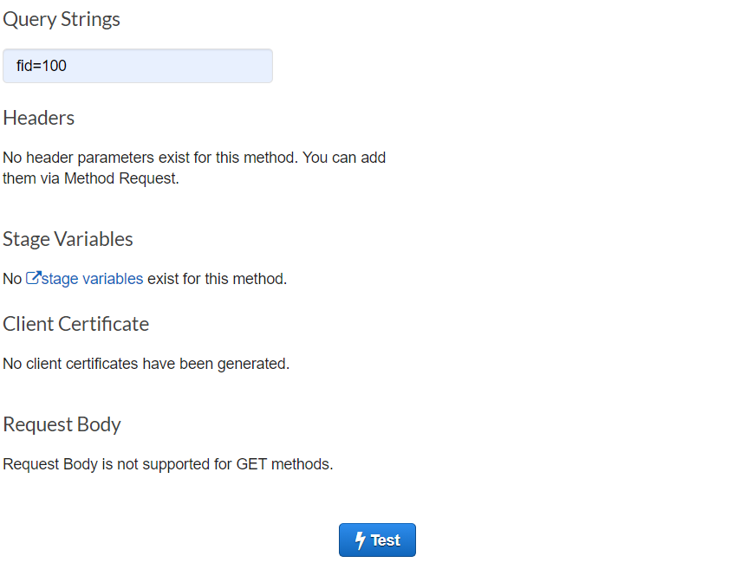

After doing so, click the “Test” button. Observe the results shown.

If the status code is 200 and the details of the design with id 100 is returned, it means we have successfully set up our API Gateway.

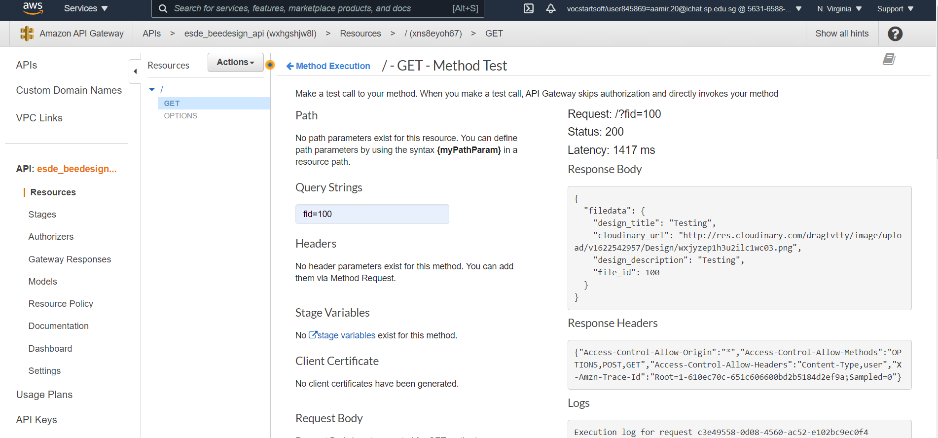

As shown in the screenshot above, we are able to get all the details, which verifies that our API is working and will not cause any issues when testing our web application!

## Testing and debugging DynamoDB, Lambda function and API Gateway, RDS

To test our code, we will head to our website and perform a login first.

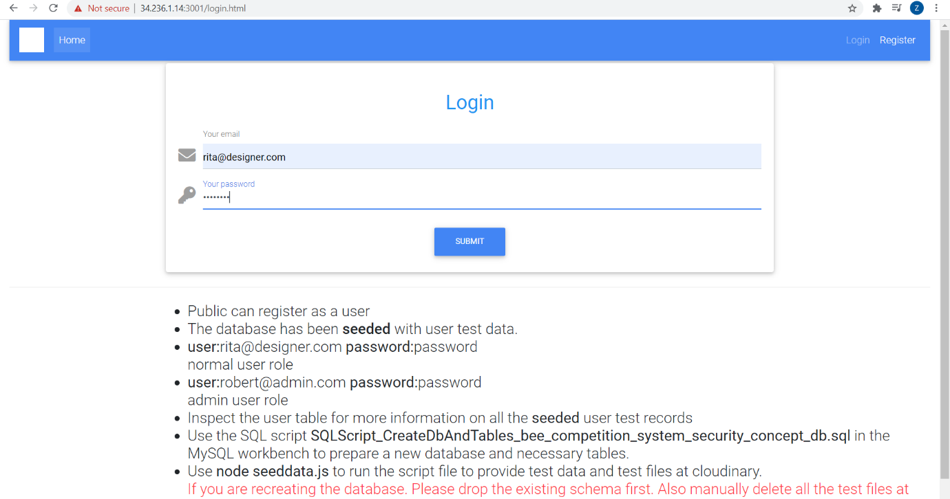

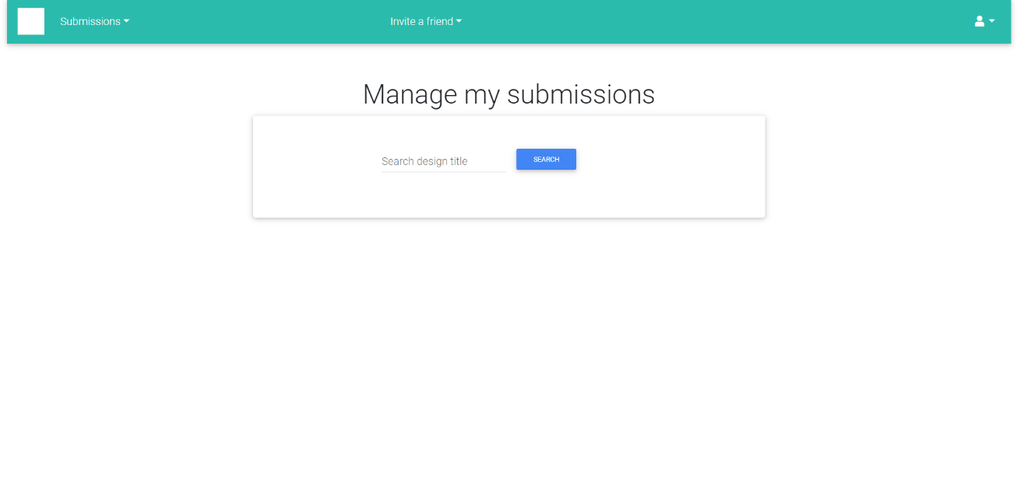After, you have logged in, you should see a similar screen below.

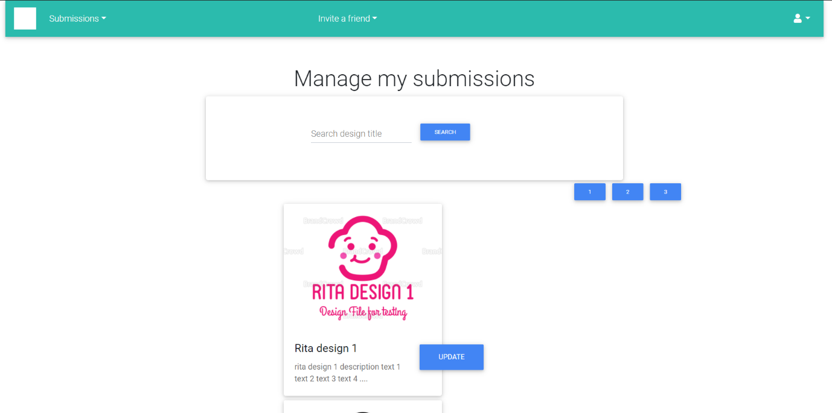Afterwards, perform a search to retrieve all the data for the designs. By doing so, it will show whether our website is able to fetch the data from RDS.

Next, we are going to test our Lambda function and API Gateway. To do so, choose any one of the designs and click the “UPDATE” button.

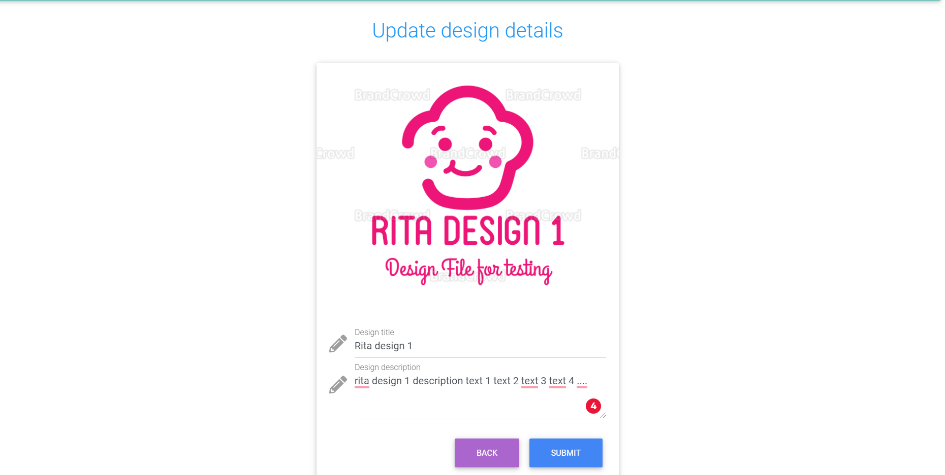

Next, head over to DynamoDB Table and change the Design Title and Design Description to any text of your choice. As for testing purposes, I am going to change the Design Title and Design Description to “testing”.



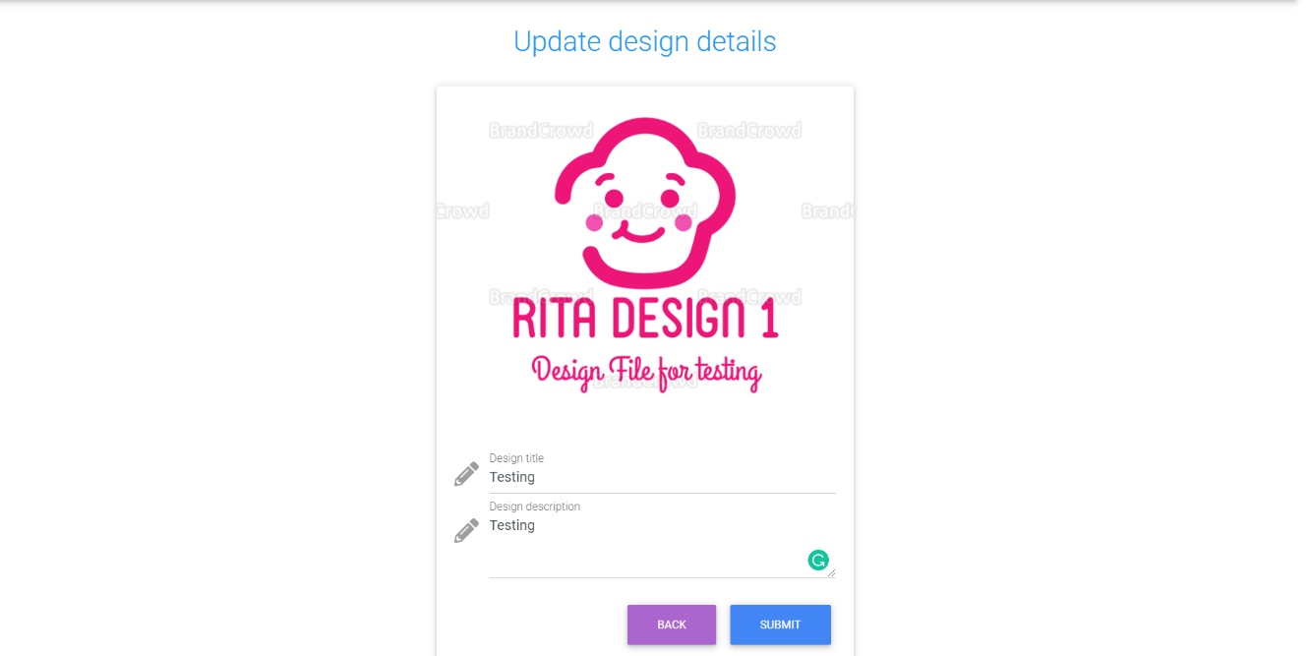After you have changed the design description and design title in DynamoDB, head back to your website and do a refresh. This will check whether the changes in DynamoDB reflect back in our website.

As we can see from the screenshot above, we can see that it has reflected back on our website successfully.

Hence, our DynamoDB, Lambda functions and API Gateway is working properly!

# Centralized logging for Web API Access

We are now going to implement security features in our web application using CloudWatch. Firstly, we are going to do Centralized logging for Web API Access.

The steps below will help you to get your centralized logging up and running

Firstly, head over to the configuration tab 🡪 permissions and click the link in blue labelled as “Role name” as shown below.



Next, you should see a similar screen below upon clicking the link.



Next, click the “Attach policies’ policies button in blue as shown above.

Search for the policy name “AmazonAPIGatewayPushToCloudWatchLog”

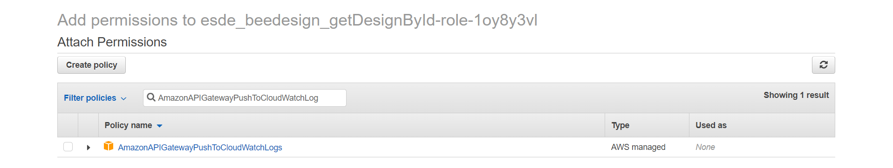

Click the checkbox on the left beside “AmazonAPIGatewayPushToCloudWatchLog” and click “Attach Policy” on the bottom right hand side.

Next, on the same page, copy the Role ARN and store it in a safe place as we will require this later.

Then, head over to rest API Gateway console page, and select the Existing REST API that we created before

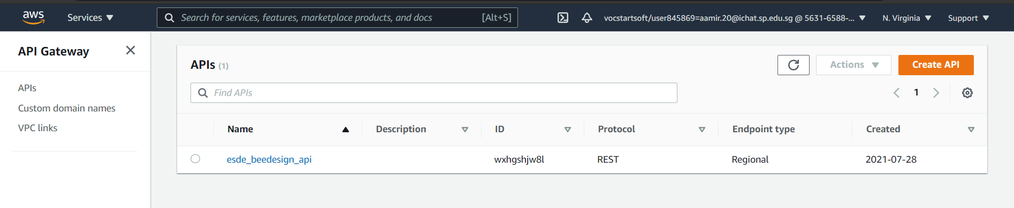

After you have done so, you should see a similar screen as shown below

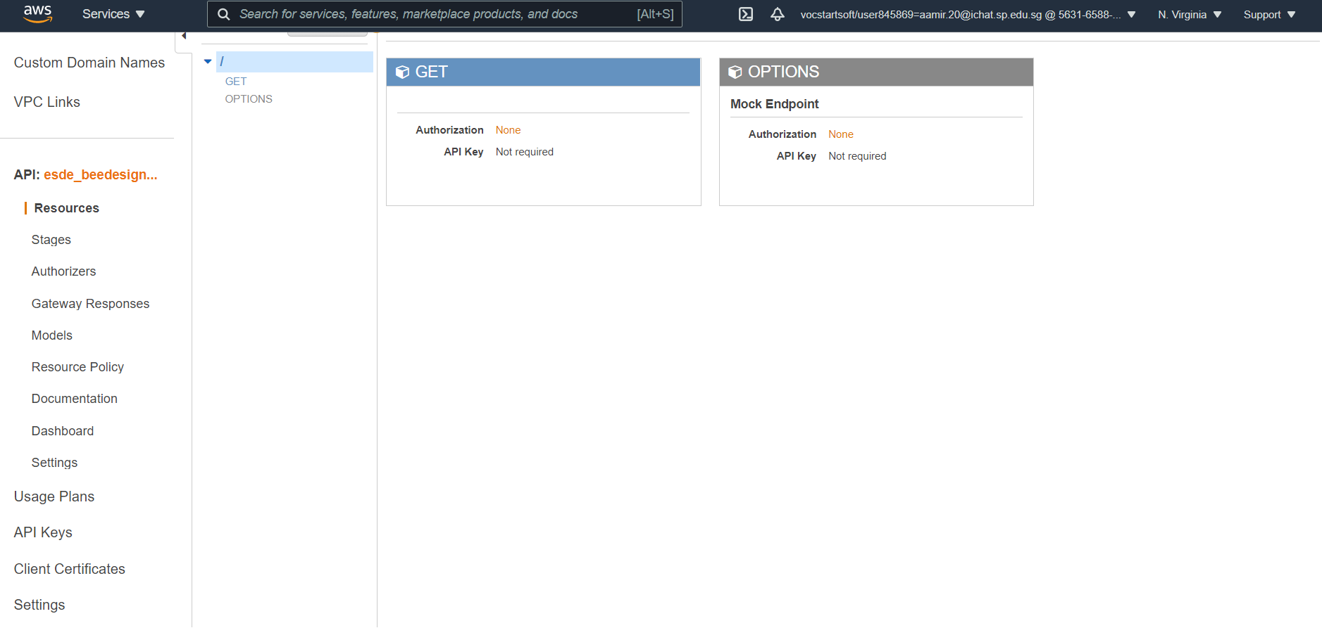

On the left-hand side panel, you should see a tab called “Settings” at the bottom. Click it.

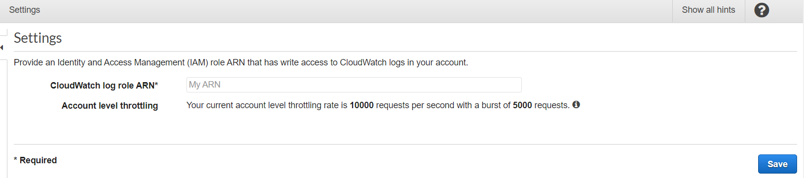

In the input field for “CloudWatch log role ARN”, paste the ARN we copied previously and click the “Save” button.

Afterwards, head back to your API Gateway and navigate to Choose Logs/Tracing in the Stage Editor. You should see a similar screen as shown below. 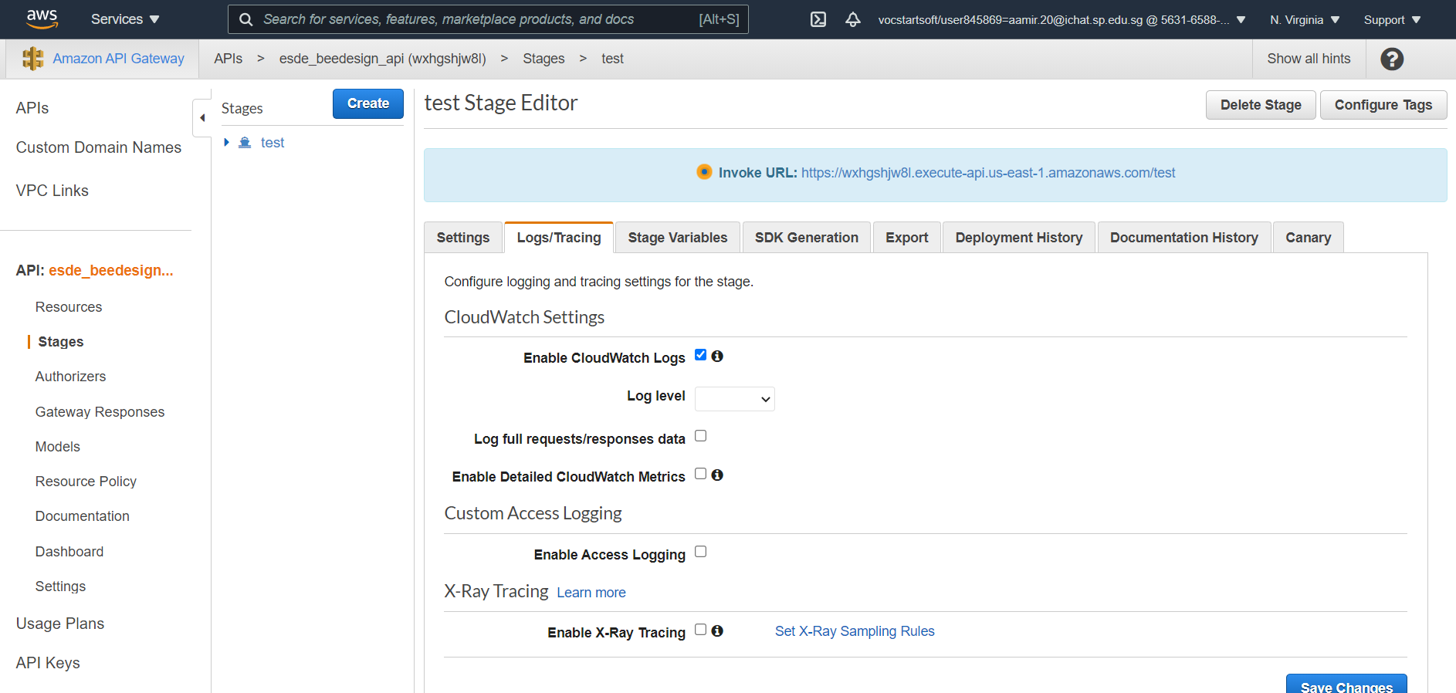

On this page, select “Log level” as “Info”

If desired, choose Log full requests/responses data to log the full API requests and responses.

If desired, choose Enable Detailed CloudWatch Metrics.

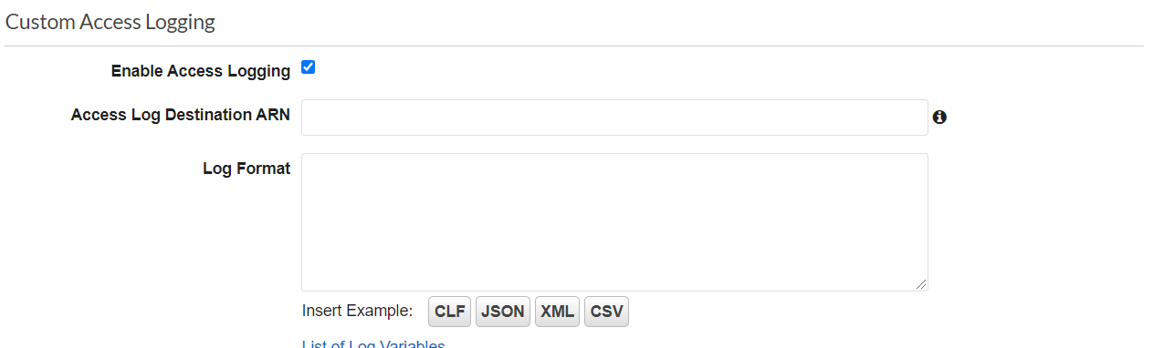We will however need to Choose Enable Access Logging under Custom Access Logging.

Enter the ARN of a log group in Access Log Destination ARN. The ARN format is arn:aws:logs:{region}:{account-id}:log-group:log-group-name. Replace the following in red to your own region, account id, and log-group-name.

Next, select JSON as the Log Format.

Afterwards, Save all your changes and you will be done with this.

We will now test to see whether the Centralized logging is working properly.

Head back to your API Gateway and navigate to Stages. Then, click the Invoke URL and right-click 🡪 open link in new tab.

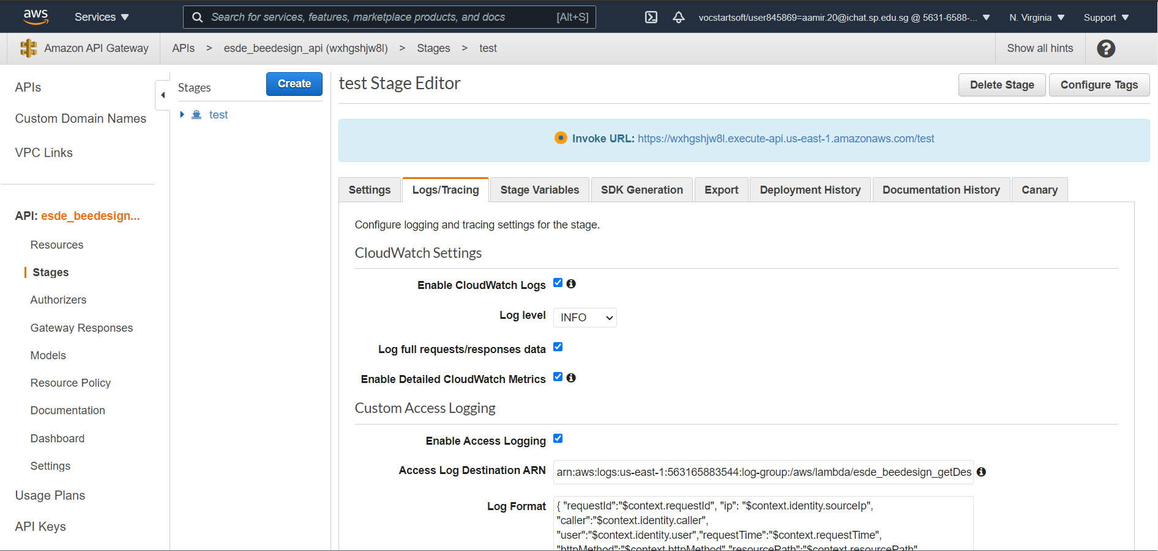

Upon opening the link in new tab, add the following to the back of the URL “?fid=100”. This would then call the Lambda function and fetch the design with designid 100.

After you have done so, head over Amazon Cloudwatch. Under Logs, select “Log groups” 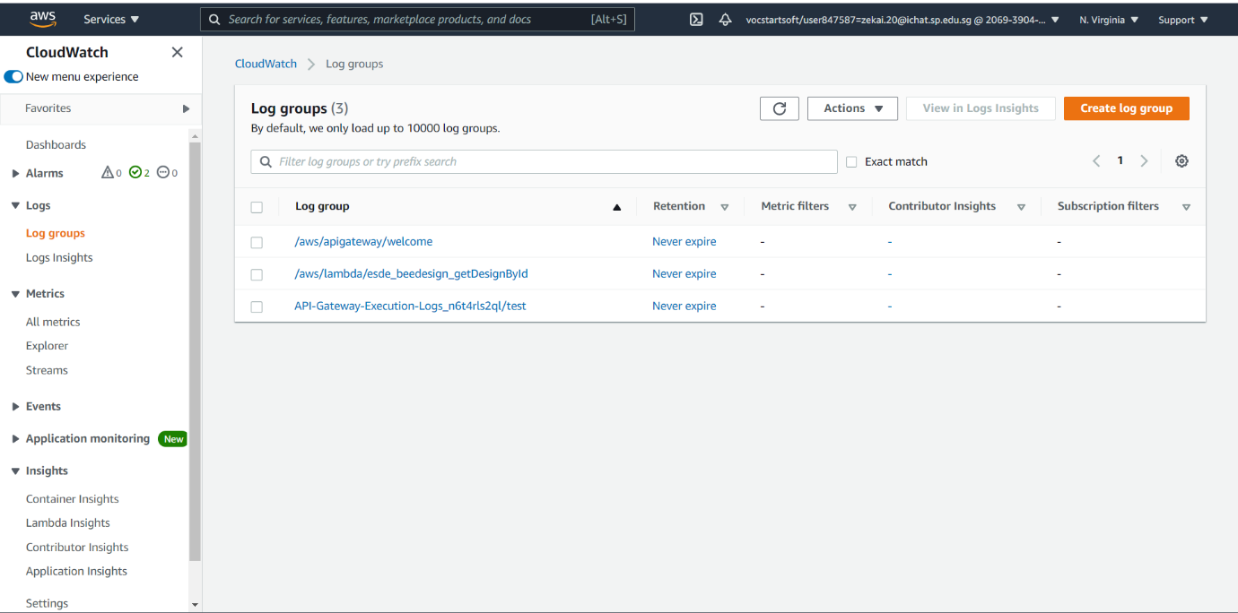

Then, click on the Log group that we are using.

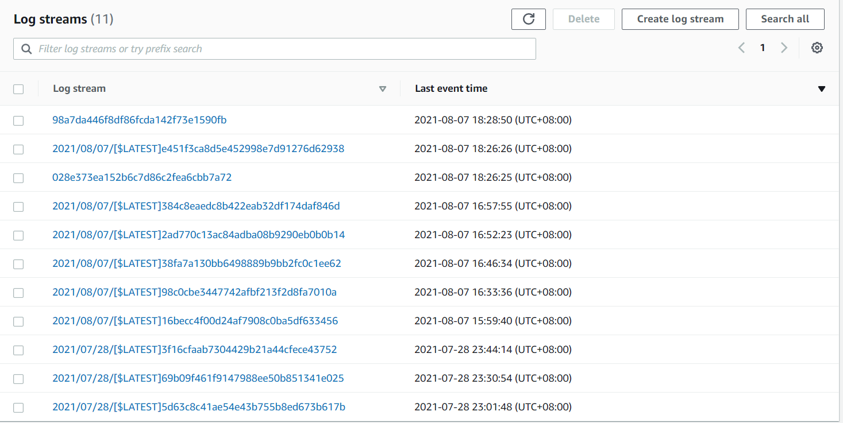

Then, under Log streams, you will be able to view the different logs. Check through the logs under the timestamp that you performed the request. Once you have found the correct log, it should display the sourceIp, requestTime, resourcePath, responseLength and httpMethod as shown below.

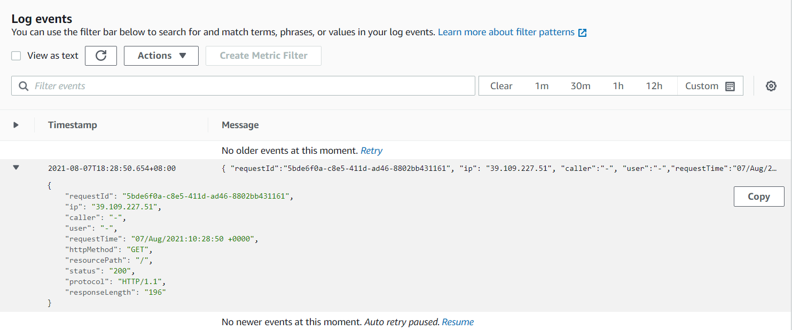

We have now successfully implemented Centralized logging for Web API Access for our web application 😊

# MySQL RDS Database Security

We are now going to implement MySQL RDS Database Security feature in our web application, to make it more secure and safer for use!

Firstly, we will need to head over to MySQL Workbench. Then, log in to your database containing all the database files. Next, head over to the panel on the left and select “administration” as shown below

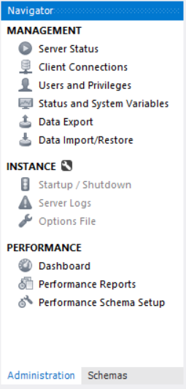

On this panel, click on “Users and Privileges” under Management. You should then see a similar screen as shown below

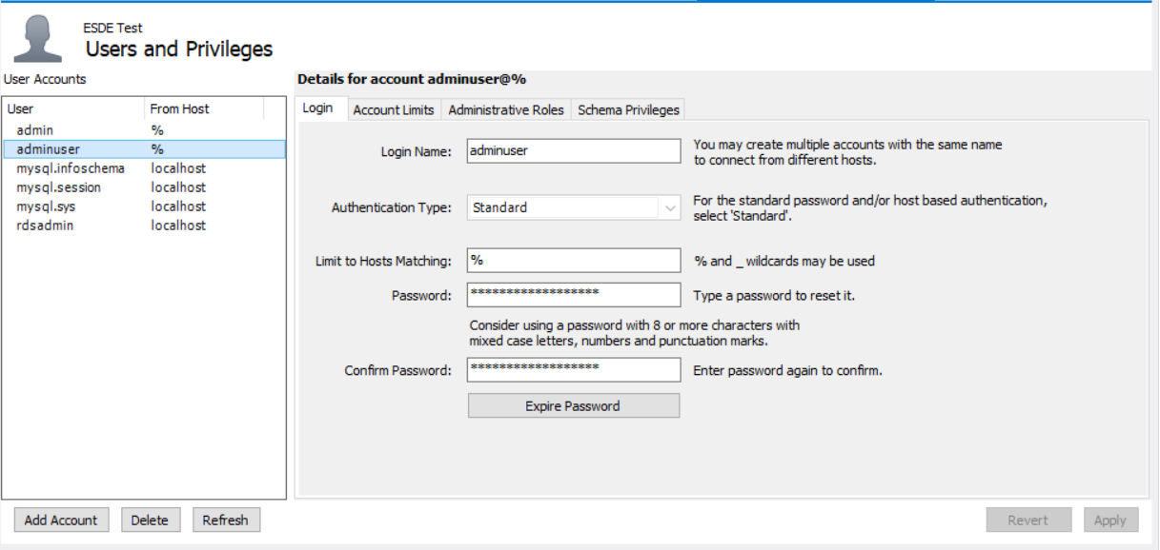

Next, on this page, select the tab called “Administrative Roles”

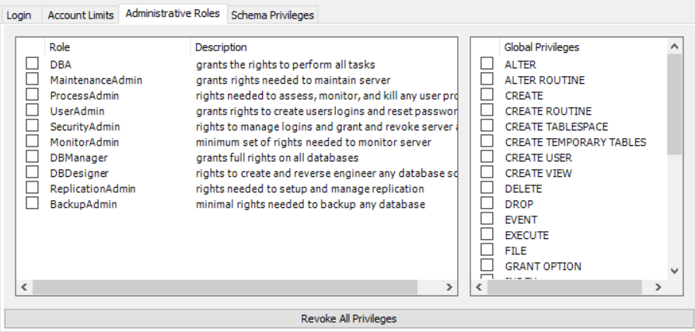

Next, under Global Privileges, give them the rights to “CREATE” , “UPDATE” and “INSERT” by clicking the checkbox beside each Privilege.

Then, Click the Apply button.

We have now completed Ensure the least privilege for database connection credentials.

Next, we are going to encrypt our RDS Database

Firstly, head over to your RDS Console page and select the Database that you wat to make use of

Then, as shown in the screenshot below, select “Actions” and you should see the “Take snapshot” button. Click on it.

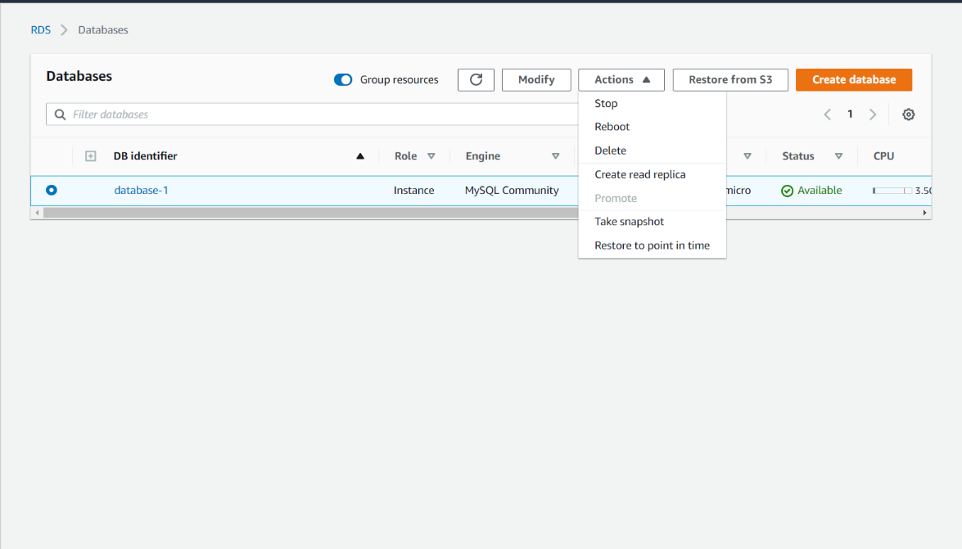

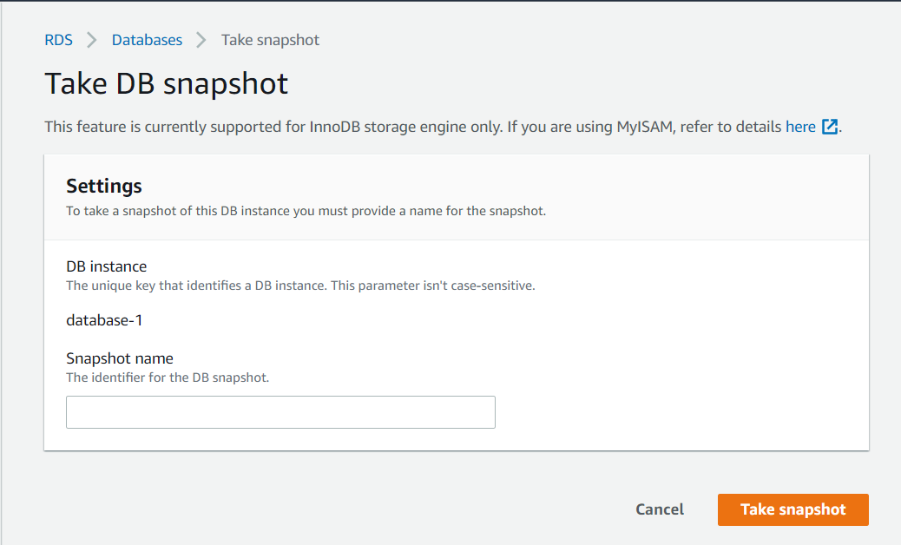

Next, you will be prompted to “Take DB snapshot” as shown above. For the Snapshot name, you can name it anything that you wish, however, we will be using “test” in this case. Once you have done entering your Snapshot name, click the “Take snapshot” button in orange.

Once you have clicked the button, you should be automatically redirected to the screen as shown below. 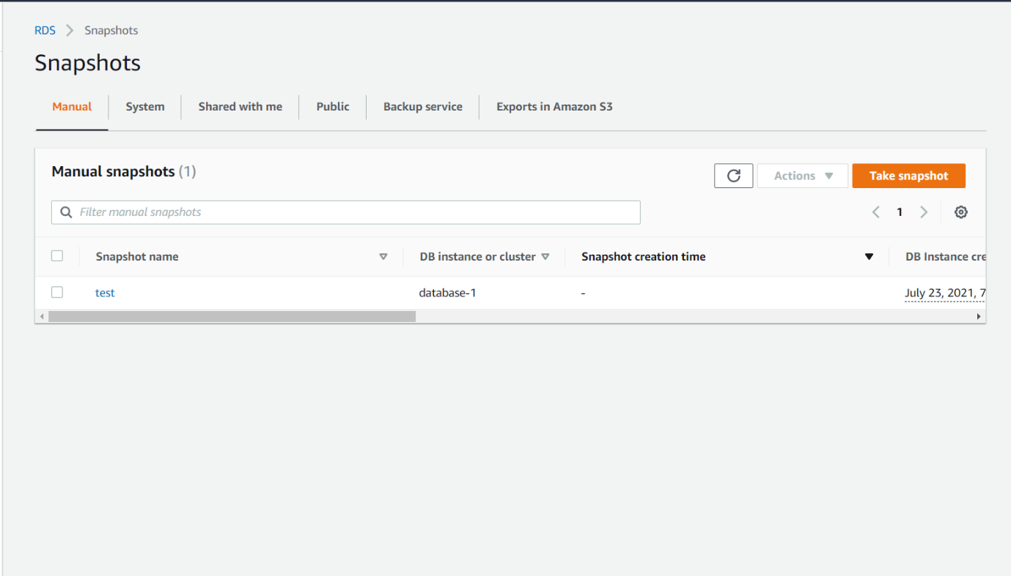

Then, select the snapshot you have just created. Then, click “Actions” and “Copy snapshot” as show below.

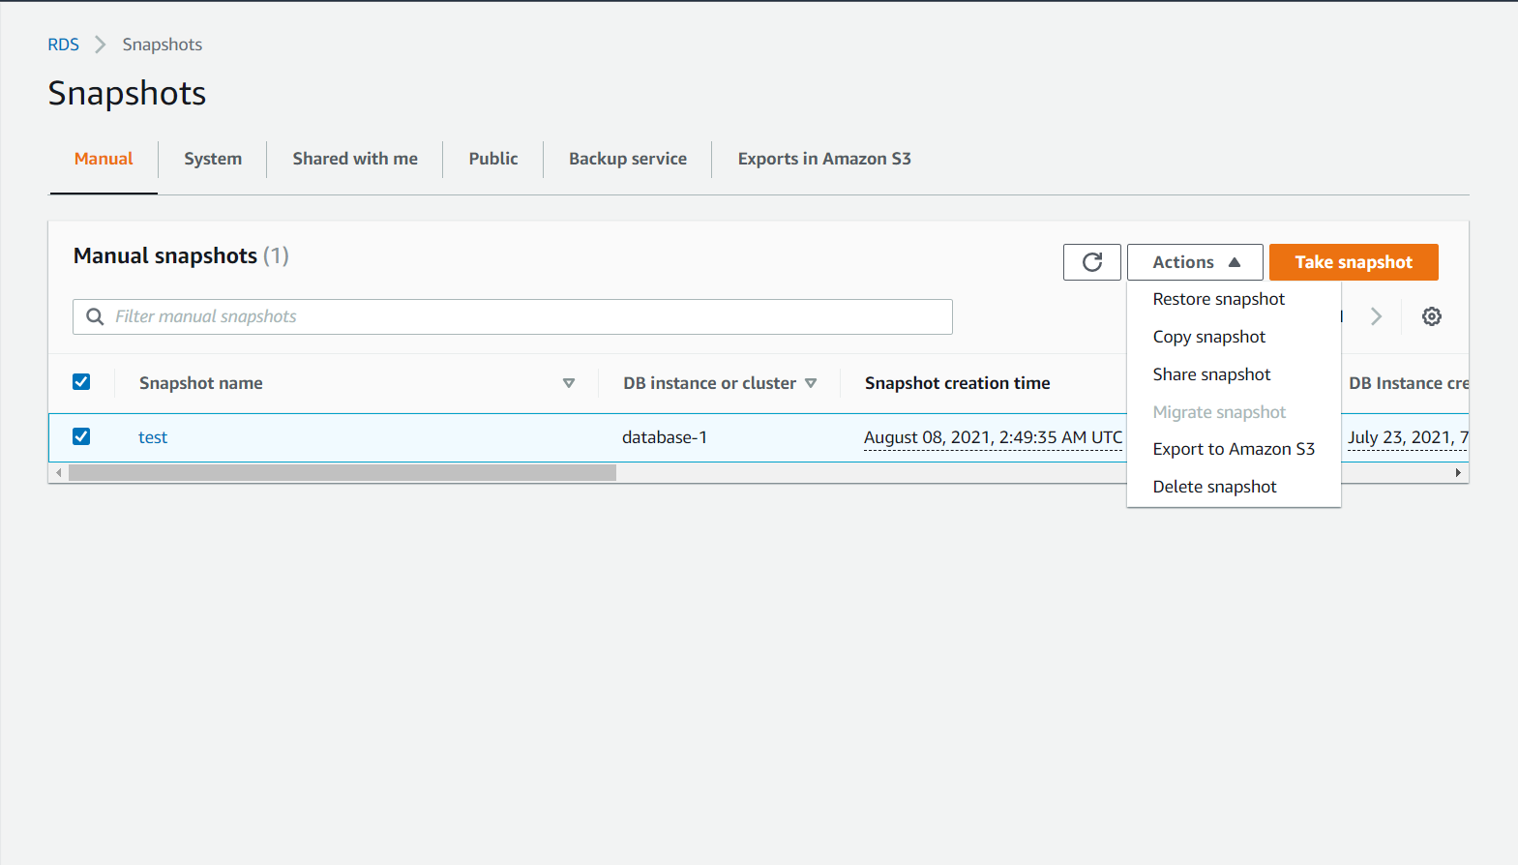

Next, you should see a similar screen as shown below to configure Settings for copying your snapshot.

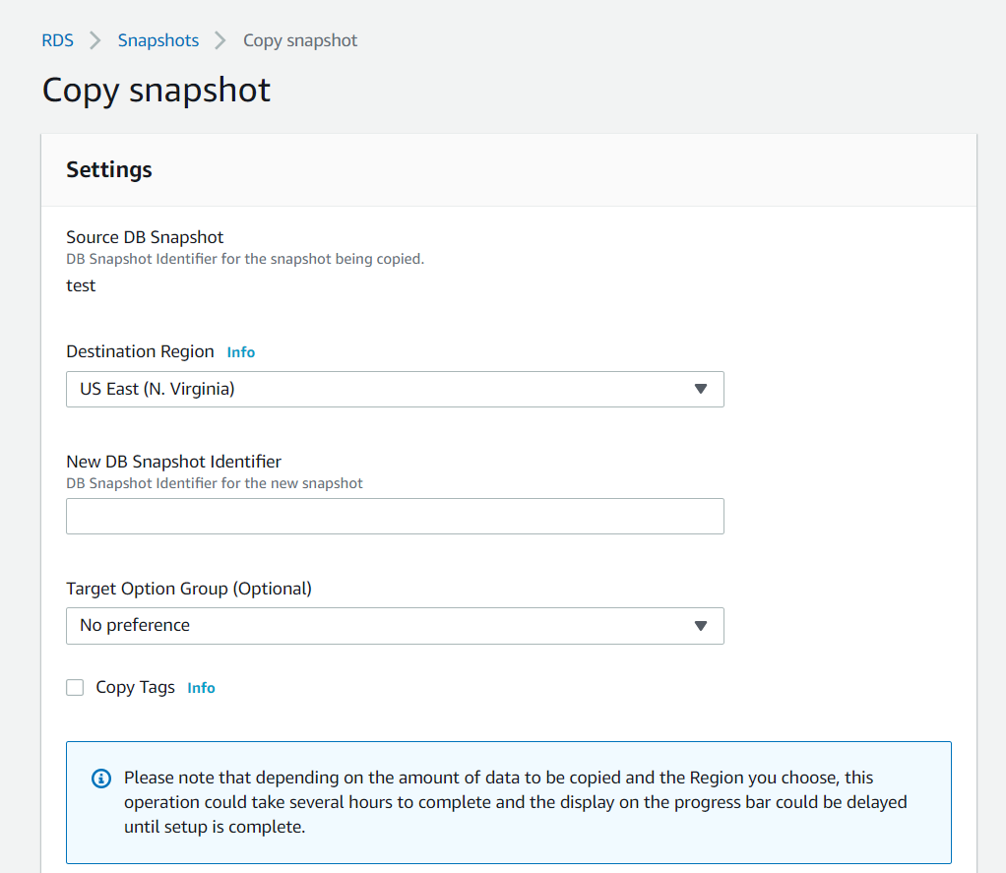

In the Input field for “New DB Snapshot Identifier”, give it a name for you to identify your copy of snapshot. We will be naming it “encrypted-test” for now.

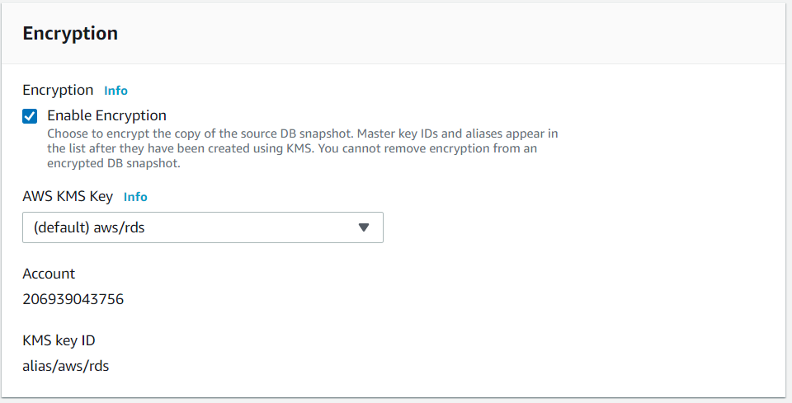

At the bottom of the page, select “Enable Encryption” under Encryption. You can then click the copy snapshot button to complete the configuration settings for your copied snapshot.

Next, you will be re directed back to the snapshot console page. Then, select the encrypted snapshot (the copied snapshot), and then select “restore snapshot” under “Actions” as shown below.

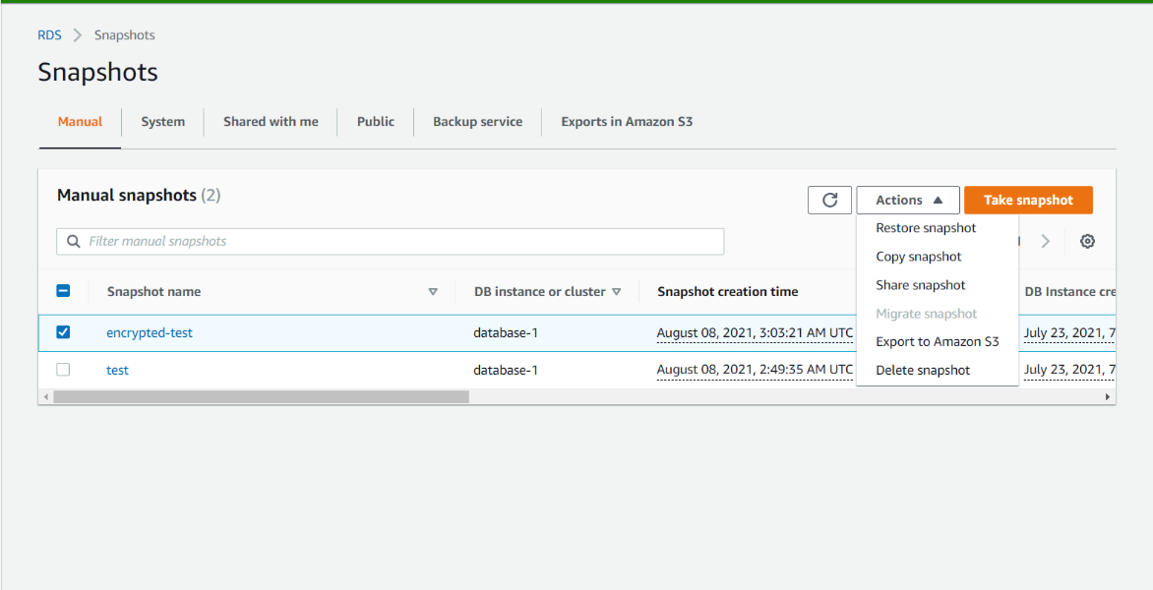

You should then see a similar screen as shown below when you click “restore snapshot.

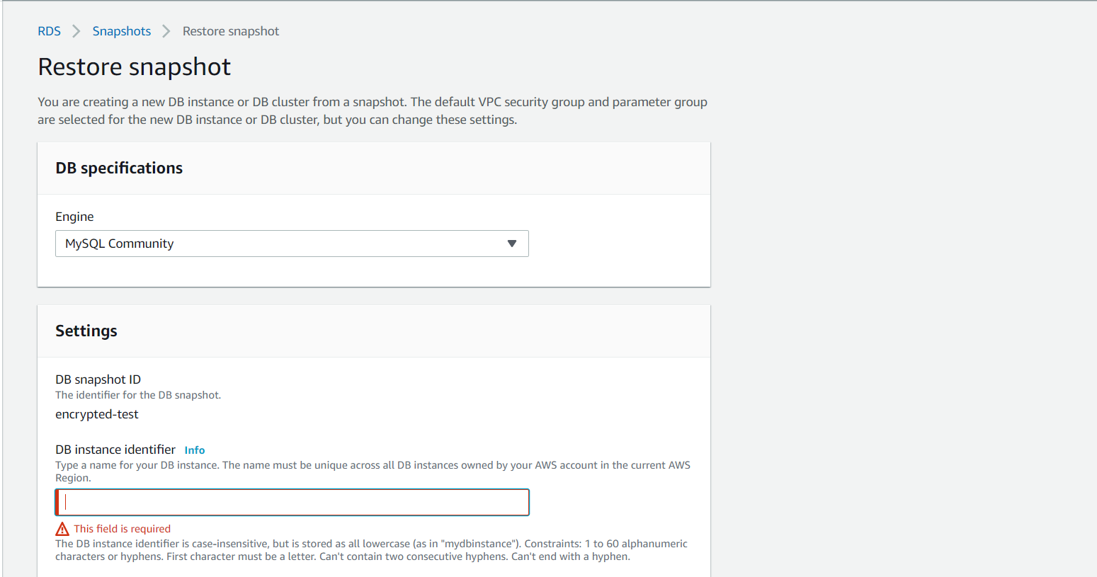

On this page, enter a new database name under “DB instance identifier”. Then, leave everything as default and click “restore DB instance”.

On AWS, databases cannot be encrypted after creation. To encrypt our database, we first have to take a snapshot of it and then encrypt the snapshot. Finally, we will create a database using the encrypted snapshot which will result in an encrypted database as well.

We have now successfully encrypted our database.

For MySQL RDS Database security, database access logging, we can head over to our RDS Console page.

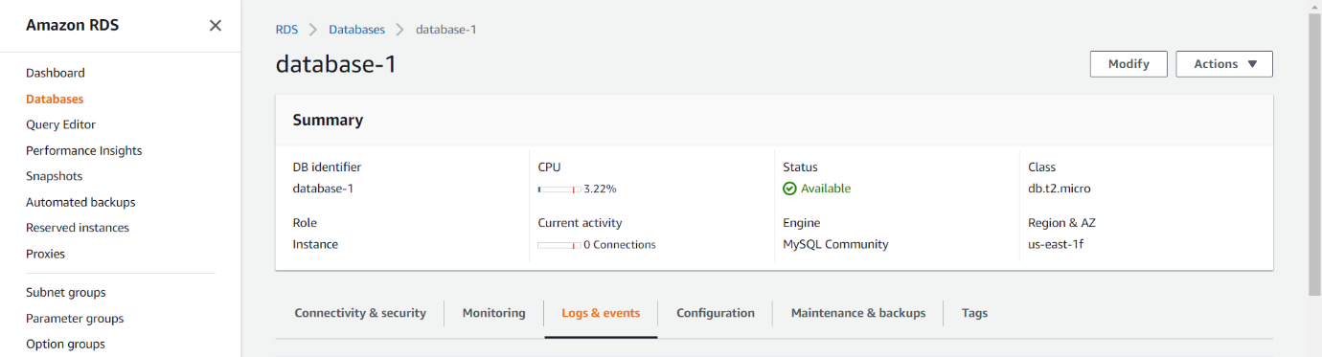

Then, we can head over to “Logs & events” and we will be able to see all the logs as shown below.

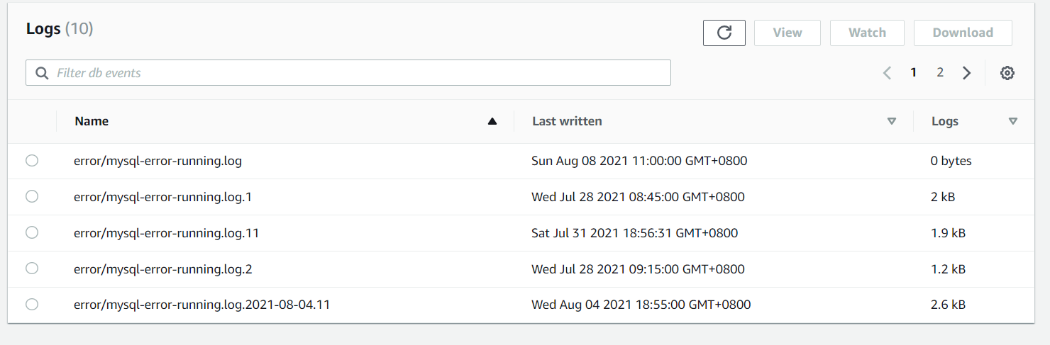

We can now see all database access logging 😊